Clinician Customizations

Workspace: Make sure that important charting activities are always available to you (so you don’t have to find them from the More tab). Optimize your main toolbar, activity tabs, rearrange & collapse navigator sections and more.

Synopsis: Choosing the Right Reports, Making Efficient Buttons. Available from Chart Review or in an encounter, these reports pull vitals, labs, discrete history or HPI data) and summarize them for quick viewing.

Snapshot Reports: Choosing the Relevant Side Bar Reports.

Chart Review: Arranging Report Segments for Efficiency in Labs and Imaging.

Care Everywhere: What Lives Where and Arranging Reports for Efficiency.

Problems: the Problems List, Problems reconciliation and how Problems, Visit Diagnoses and History interact.
You already know about moving and Problem to the Visit Diagnoses for Problem Based Charting. Did you know that you can move a Problem to the History and the Overview becomes the detail? Or vice versa? Learn the Power of the Right Click!

Level of Service (LOS): how to change or add speed buttons to LOS
In Basket: Granting Access and Attaching your Partner’s InBaskets.

In Basket: MyHealth Utilities and Quick Actions (focus on PAP/HPV and OB labs).
The best practice is to use MyHealth capable actions whenever possible Build QuickAction to efficiently disposition results.
Orders: “Future” versus Standing and Recurring Orders.

Referrals: Getting a Consult Inside or Outside WHA. Referrals are orders and are trackable.

Preference Lists: Meds, Imaging, Referrals, and Surgical Case Request -Save Time while you’re with patients.
Setting up custom order preferences can speed you up, so you spend less time filling out individual fields inside data intensive orders (medications, imaging,
referrals and case requests).

Preference List Editor: Common Diagnoses, Routine Diagnoses, Reason for Call
Preference List Composer: Look at what other users have, organize you own,

SmartPhrases: Looking at your SmartPhrases.
You already know how to create these or steel from your partners. Now is a perfect time to look and see if you still have access to ones you created as a prior WHA provider or if you will need to make new ones.

Macros: Consider creating these for efficiency.
Like your SmartPhrases, you may have created some of these in the past. Look to see if they are still available to you or simply create new ones for ROS, PE or even your common procedures.

WHA SmartSets: How to favorite SmartSets.
SmartSets help speed up your documentation by pulling together everything you need in one place. Some key documentation sections found in SmartSets: Reason for Visit, Diagnosis, Orders, Patient Instructions and Follow-up. Favorite your more commonly used SmartSets for easier access.

Charge Capture: How to favorite commonly used charges.

Exercise 1: Ambulatory Quick Wins

Changing Home Workspace

Even though you might have multiple startup activities, only one opens by default. You can set the one you use most often to be the default. Since you’re primarily in ambulatory settings, you might want your Schedule or your dashboard to be the default.

- In the top-left corner, under the Epic button, click on the startup activity tab that you want to be the default whenever you log in.
- Click the star in the upper-right corner of that activity. The star will turn yellow.
  - If you want a different startup activity to be your first tab on your Dashboard, click and drag it to the first position.
- To reset your default startup activity to the first tab such as the Dashboard, unselect the star on the activity you had selected previously.
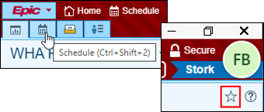
- Click OK in the Default Startup Activity box that opens.
- To avoid this window opening again if you change this setting in the future, check the Do not show me this again box.
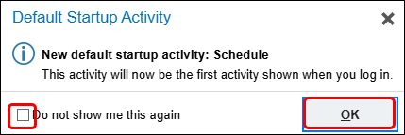

Hyperspace Toolbar Customizations

The Hyperspace Toolbar is customizable by using drag and drop to rearrange and remove activities that are not needed.

- Click and drag OR Marketplace into the Remove from My Toolbar trash can.
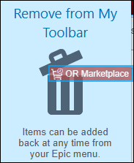

If you don't see the buttons you want to see on your main toolbar, you can add them.

- Click on the Epic button in the upper left and click the push pin icon next to your desired activity and select Add to My Toolbar.
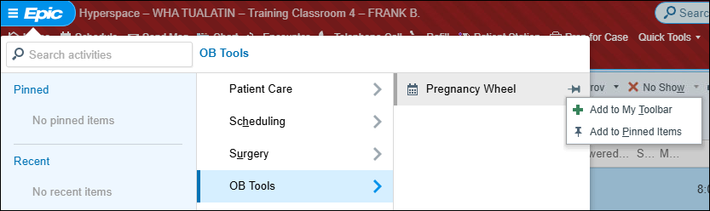
- Click and drag your toolbar buttons to rearrange their order.
- You can use CTRL+1 thru CTRL+0 as shortcuts for these buttons.

**If you are working out of a Legacy hospital, you can hover on Surgery and click Status Board to add it to the hyperspace bar.

Adding Reports to Preview Pane- Visible from the schedule view
- Click the to open the preview selections.
- Check Bottom to change the view.
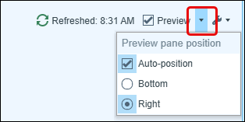
- OB Snapshot is the default report.
- In the top right corner of the report pane, click and select Add or remove buttons from toolbar.
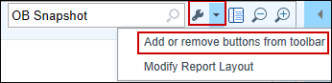
- In the Add or Remove Buttons from Toolbar window:
  - Report field: Look up a report you want as a button.
  - Button Name field: Enter a free-text name for the report. Brief names allow more buttons to fit on the toolbar.
  - Note: The top-down order in this window is the left-to-right button order on the toolbar. Use the and buttons to change their order.
- Reports you can add:
  - Snapshot – Patient
  - WHA Pregnancy Episode
  - Visit Orders and/or Visit Charges
  - Rooming Report
  - AMB Facesheet.
- Change Button Name as desired.
- Click Accept. The report buttons appear on the toolbar.

Follow the steps below to change the layout of the report on your schedule.
- At the top of the report pane, on the far right of the report toolbar, click and select Modify Report Layout.
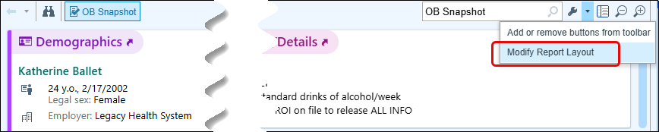
- Click the section you want to move and drag the section to the new location. Release the click to place the section in the new location.
- Click Accept to save the new layout.

Set the Default Report

You can have different schedule views such as the entire department schedule, just the patients scheduled in this department, or all patients in any department scheduled with you. Each of these views can have a default report and you can change that report to be the report you use most frequently.

- On the top left of the schedule, beneath the schedule toolbar, click the current schedule view (often the view is your name) to see the list of views:
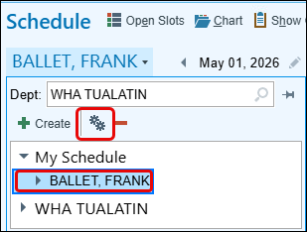
- After clicking on the schedule view you want to edit, click .
- Select the Advanced tab.
- In the Default appointment report override field, choose the report you want to use as the default.
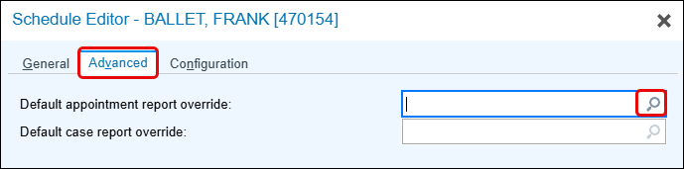

Schedule – Choose Which Information Appears
You can see desired patient information in columns on your schedule as well as add and change the order of the columns on the schedule.

First, you need to Pin your calendar.
- Click the down-arrow next to your name.
- Click the Pin next to the Dept.
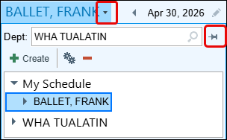
- Right click on the WHA Department folder and uncheck the Show All Providers box.
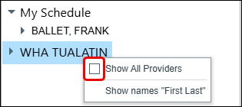
- Now choose which personalized schedule view to personalize. On the top left of the schedule, beneath the schedule toolbar, click the current view to see the list of views:
- After clicking on the desired view to edit (your provider name), at the top of the view list window, click .
- To change the columns, use the General tab of the window that opens:
  - Reorder columns: In the Selected Columns list, click or at the bottom.
  - Add a column: In the Available Columns list, use the Search box to look up desired item > click on a desired column > click Add Column. Some frequently used columns are:
    - H&P Note, H&P Status, or Case Request: For surgical workflows
    - Pre-Charting (Has Note): Indicates whether pre-charting was done.
    - My Sticky Note: Shows the sticky note icon to launch My Sticky Note from Schedule and Patient List.
    - Last Enc this Prov: Shows the last encounter you had with the patient.
  - Remove a column: In the Selected Columns list, select the column and click Remove. For example, you might want to remove the Provider column if your schedule view shows only your visits.
    - Travel Advisory
    - Unanswered Questionnaire
    - Referring Provider
    - eCheck-in Status
- Click Accept to save your changes.

After adding and removing columns, they may not all fit on the screen. It will be helpful to adjust the width of the columns to be able to see all of them without having to scroll.
- Find the column that needs to be adjusted.
- Hover the cursor on the gray line at the end of the column.
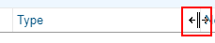
- Click and drag side to side to adjust the width.
- Adjust so that all columns can be seen without scrolling.

Exercise 2: Workspace and Chart Review:

Activities Bar
You want to make sure that important charting activities are always available to you, so you don’t have to search from the More tab (upper right corner).

Tasks: Go into any Scheduled patient to access Pre-charting. You may already have these activities but let’s make sure: If you do not see Synopsis, History, or MyHealth Results Release in your activity tabs across the top… follow steps 1 & 2 below if you chose to add these tabs.

- Go to down facing arrow: choose and favorite when you click on the pin to the right of the label: History, Synopsis
- The down facing arrow is also where you can access MyHealth Utilities, choose and favorite MyHealth Results Release or look at Patient Message Review
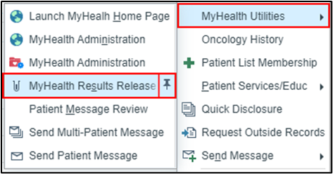

Filter to Find Information Faster

One of the challenges to efficiency is information not being easily discoverable. On a given tab in Chart Review, you can set up filters so that you can quickly summarize the information you are interested in. For example, when you go to the Media tab you might want to only see images of a particular exam (colonoscopy or mammogram), or on the Encounters tab you might want to see visits with a particular reason for visit.
When you open a tab in Chart Review, you will see some pre-set filters that appear as a series of check boxes next to the Filters button.
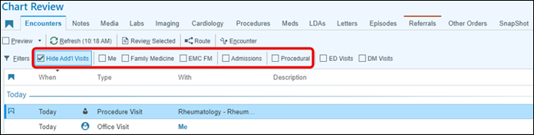
If you don't see a filter that meets your need, you can build your own Quick Filter and save it, so it is one-click away the next time you need it.
- In Chart Review, go to the desired tab and click Filters.
- In the filter pane on the left, select the criteria and specific values you want to use for your filter.
- If you don't see the value you want to include ﴾because the current patient doesn't have that value in their chart, use the lookup field (Contains... search bar) below the criteria list and your filter will include that search term.
- Select if you want this to be an inclusive or an exclusive criteria using the Include and Exclude buttons.
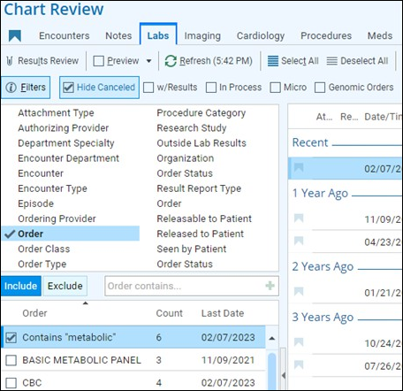
- At the bottom, click Save as New Filter.
- Enter a free-text name for your Quick Filter and click Accept.
- The filter appears as a check box to the right of the pre-set filters.

Update a filter you created
You can make updates to filters you previously created.
- In Chart Review go to the tab that has the filter you want to update.
- Click Filters.
- Select the filter you want to update.
- Change the filter for your needs.
- Click Save <Name of the Filter> to update the filter.
  - If you want to create an additional filter and keep the old filter, click Save as New Filter.
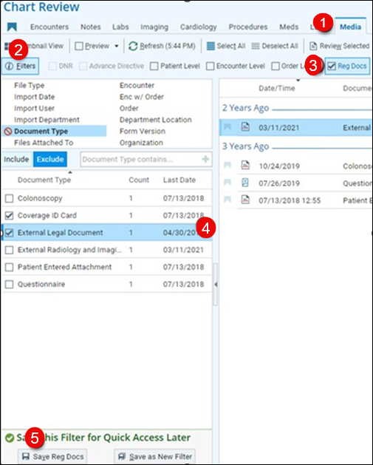

Delete a filter you created
- In Chart Review, select the tab that has the filter you want to delete.
- Click the three dots on the far right.
- Select Manage Quick Filters.
  - Manage Quick Filters window opens.
- Select the filter you created that you want to delete and click Delete.

Synopsis – Trend Data, build patient-specific view and customize

Synopsis can display a large amount of varying types of clinical data in one view, tracked over time. For example, you can analyze information about vitals, medications, labs, procedures, flowsheet information, answers to questionnaires, and other data relating to patient care in one Synopsis view.

Trend Data: It allows you to build graphs from the information as well as copy that information into your notes.

- In the patient's chart, go to the Synopsis activity tab.
  - If the tab isn't available, use the search ﴾CTRL+SPACE﴿ to open it.
- In Synopsis, use the buttons at the top to choose a view related to a certain condition, such as diabetes or hypertension.
- At the bottom of the activity, choose the interval you want to view.
- In the grid, hover over the row and click the graph icon next to the items that you want to graph.
- As you graph data, the labels change to match the color of the corresponding graph lines.
- In your production environment, you may just need to click the rows instead.
- Any selected medications and procedures appear in the timeline below the graph. Hover over them to see a highlight in the graph to visualize how a particular treatment might have affected vitals or lab results.
- To view a report about an item ﴾result reports, order reports, past notes, etc., click the contents of a cell. Click on the top right to close a report.
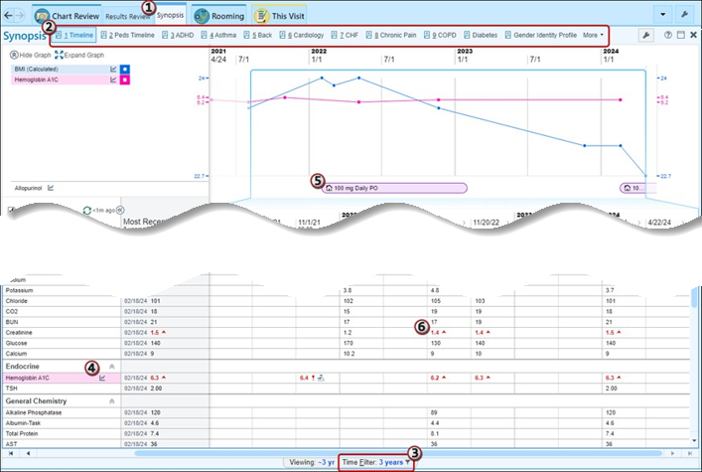
Build a Patient-Specific Synopsis: When reviewing trends in Synopsis, decide which items are most relevant for a patient and add that data to the Patient Spotlight. The spotlight permanently appears at the top of the activity for that patient, regardless of Synopsis view, so you can quickly track the data even when you switch Synopsis views.
Note: The items you put in the spotlight are specific to that patient and appear only to you.
- In a Synopsis view's grid, hover over an item until you see a star icon.
  - In your production environment, this may be a pushpin icon instead.
- To remove an item from the spotlight, in the Patient Spotlight section click the star again. To graph these items, you still need to choose the graph icon even if it's a spotlight.

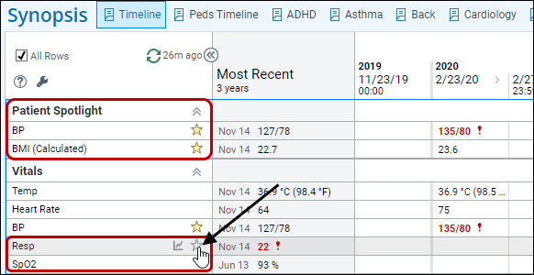

Customize: You can pick which Synopsis views should be buttons on the activity toolbar and can control their order.
- Click on the right side of the activity toolbar.
  - The Add or Remove Buttons from the Toolbar window opens.
- View: Choose a Synopsis view. Select the magnifying glass in one of the rows to see all your options.
- Display Name: Enter a free-text name for the button.
- Continue to add reports as needed.
- Use the and buttons to change the order in which the buttons appear on the toolbar.
  - The report in row 1 will be the default view when you open Synopsis.
- Click Accept.
Below are some reports you may find useful.

 | Report | Display Name (rename the button something small)
1 | LEAP WHA PATIENT QUESTIONAIRE SYNOPSIS | WBA
2 | AMB SYNOPSIS OBG | GYN Wellness
5 | AMB PHQ QUESTIONNAIRE SYNOPSIS | PHQ 2/9
 | Report | Display Name (rename the button something small)
7 | LEAP WHA UROGYN INTAKE SYNOPSIS | UroGyn Intake
8 | Amb UroGyn PopQ Exam | PopQ
Other synopses that may be helpful for specific individuals such as UroGyn.

SnapShot

- From within an encounter (can be in Pre-charting), go to the Notes located to the right of your screen.
- Click on the SnapShot activity.
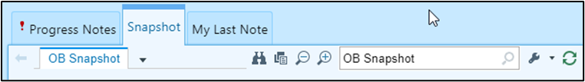
- Find the wrench located on the right of the SnapShot Search field.
- Click on the wrench and add/move the following into the top positions, using the up and down arrows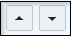.
- Rename the report something small to allow more buttons across the top. Note that OB SnapShot is always first (before #1 below):

 | Report | Display Name (rename the button something small)
1 | Snapshot-Patient | SnapShot
4 | Wt | Ht Wt BMI BSA
5 | AMB FACESHEET | Insurance/Interpreter
6 | The rest don’t really matter… not so good.

- You can also arrange reports in the Snapshot activity located to the Left of your screen. You may find this helpful if you need to access reports when not an Encounter.
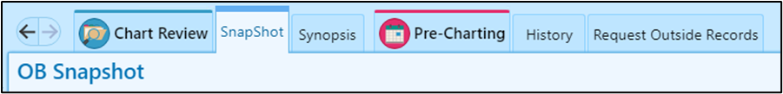

 | Report | Display Name (rename the button something small)
1 | Snapshot-Patient | Snapshot
4 | Wt | Ht Wt BSA BMI
5 | AMB FACESHEET | Insurance/Interpreter

OB & SnapShot shows when someone’s Birthday is near. AMB Patient SnapShot and SnapShot-Patient show the patient’s future appointments.

Workspace – Optimize Your Activity Tabs

You must be in an active visit encounter to proceed with this task. Please consult your trainer for guidance before continuing.

When you are in a patient chart, activity tabs are on the top of the patient’s workspace.
If you frequently use an activity on the More menu , save clicks by moving it to the main set of activity tabs. You can add and remove activity tabs, as well as modify their order and appearance.
Note: Changes to activity tabs are encounter type-specific. For example, activity tabs you add while in a telephone encounter only impact telephone encounters.
- In a patient workspace of the desired encounter type (office visit, hospital, etc.), expand the More menu with the downward arrow.
- Add an activity tab to your workspace:
  - Click the push pin next to the activity you want to add or…
  - Click and drag the item from the More menu to your activity tab.
- Tabs can also be reordered via drag and drop.
You can also modify the appearance of the activity tabs and the tabs in the sidebar,
- Right-click the tab you wish to change.
- You will get different options depending on if it is the activity tabs or a sidebar.
- Some of the options you will see include:
- Mark as Important: adds an icon to the tab.
- Change Highlight Color: changes the background color behind the icon.
- Move to More Activities: takes a tab you don't want pinned and nests it back under the More menu.

Workspace – Rearrange and Collapse Your Navigator Sections

You must be in an active visit encounter to proceed with this task. Please consult your trainer for guidance before continuing.

If you have navigator sections you don't frequently use, move those to the bottom of your navigator and move the sections you do use to the top of your navigator.
To rearrange the sections of a navigator:
- Click the three dots in the top right corner of the navigator and select Modify Layout.
- Drag and drop the sections into your preferred order and click Accept.
To collapse sections of a navigator by default,
- Click up arrows in the top right-hand corner of the section.
- Select checkbox to the left of Collapse section by default.

Diagnosis Entry – Manage Diagnosis Speed Buttons

In the Visit Diagnosis Section of the This Visit activity and on 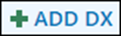 the of the visit taskbar, you will have three lists of Diagnoses:
- Previous: Diagnoses the patient has previously had recorded in the current specialty
- Problems: The patient's current problem list
- Common: A list of diagnoses you can edit
For each, you can choose whether it appears as a button that you need to click to see the list...
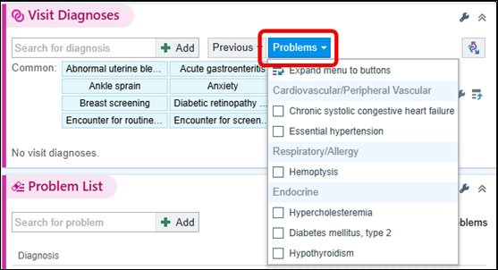
…or displays as a series of Speed Buttons:
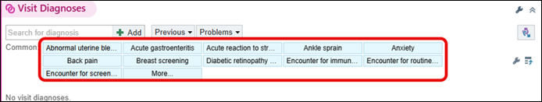
- Go to the This Visit activity > Visit Diagnoses section.
- Click the list you want to change to speed buttons (for example, Problems) > Expand menu to buttons.

To change it back, on the far right of the buttons display, click .

Add a Diagnosis Speed Button
Often there are diagnoses that you routinely enter that won't be on the patient's problem list. Create speed buttons that appear on the Common diagnoses list to make them easier to find.

To minimize the number of diagnosis calculator clicks required, choose a specific diagnosis. An example would be Uses intrauterine device for birth control, which leaves you with no extra clicks for specificity…
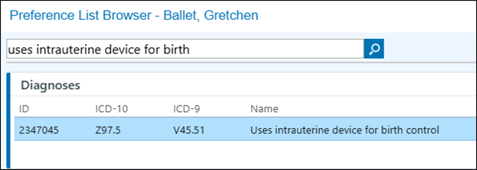
…whereas just using encounter for birth control leaves you with 3 clicks.
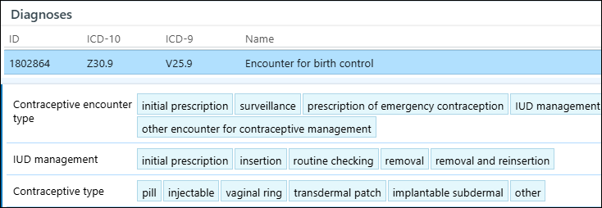
Use these steps to add speed buttons to your Common diagnoses list:

- To the right if the Common diagnoses list, click .
- In the Window that opens, in the next available row, look up the diagnosis you want as a speed button.
- Optionally, use the Caption (Optional) field to give the button a free-text name.
- Click Accept.

If the diagnosis you want to add is already listed in the Visit Diagnoses section, you can easily add it as a speed button.
Hover over the diagnosis you want to add > right-click > Add to Common Dx button list.

When searching for diagnoses, less is often more. Each new character you type increases the risk of mistyping and not finding what you are looking for. You then must start over and you've wasted several clicks. Partial name matching allows you to type just a few characters of multiple terms and find what you are looking for. Instead of typing out Gestational Diabetes, try typing GDM.

Bonus Tip: You can also add a visit diagnosis directly from the Problem List. To add a problem to the patient's visit diagnoses, click next to the problem in the Problem List section. Note: means that a problem has been added as a visit diagnosis.

Problems

Problems on the Problems List, Visit Diagnoses List and History (list) can be “pushed” back and forth. You already know about moving a Problem to the Visit Diagnoses for Problem Based Charting. Did you know that you can move a Problem to the History and the Overview becomes the detail? Let’s look at the Power of the Right Click!
Sometimes, it can be a struggle to manage problem lists that are very long. We can adjust the way problems are sorted.
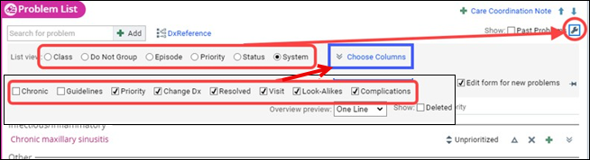
- Click the wrench and change the list view (ex. system or priority).
  - Most providers at WHA utilize the "Do Not Group" feature, as it offers the most comprehensive view of the patient's problem list.
- Can use priority as a way to quickly identify the problems you most care about.
  - This won’t impact how others see the problem list (ex. marking hypertension as high priority will not automatically appear for the other specialist).
- Can also choose columns to see more or less information (ex. clear the checkbox for the Sort Priority column if you don't prioritize problems.)
- Add a problem to today’s visit diagnoses.
  - Move a generic problem list diagnosis to the visit diagnoses (ex. Pregnancy).
  - It is important to keep an accurate problem list and update the diagnosis code itself to be as specific as possible. More specific diagnoses will decrease the likelihood you’ll be prompted to add more details during the encounter.

You may choose to tackle the following task once you are in clinic seeing patients.

Tasks: Do this from Pre-charting. Go to a Wellness Visit, preferably someone who needs Problem Reconciliation.
- Reconcile Problems to the Problems List.
- Take reconciled Problem and Change Dx to something better (like Headache to Migraine with Aura) or open the Details and look up DxReference.
- Add Overview notes such as “hot weather and high humidity; 3 times a year” (any meaningful comment).
- Take Migraine with Aura and RIGHT-CLICK and see all the options. Add to Medical History.
- Go to History Tab and see this added in Medical History.
- Take Problem from Problems list (ideal would-be Severe Pre-eclampsia or other Pregnancy Problem) and RIGHT-CLICK
  - Demonstrate Add to Medical History and Resolve. This is ideal of GDM, Preeclampsia, Severe post op complication; something you don’t need to manage anymore (can resolve) but is important history.
  - Demonstrate Search Active Guidelines: this launches Up to Date on that topic!
- Care Coordination Note. “Enter MFM Co-Management” or MD-Only/Moderate Risk or “Transfer to WHA-TA at 32 weeks for Prov Portland Delivery.” These notes can be changed but there is a running History that shows changes over time.
  - Here one can add consulting Specialties (Pain Management: Dr. So-and-so). THIS IS VISIBLE IN Care Everywhere

Note Template Speed Buttons

There may be some templates and SmartPhrases you would like to have quick access to at the top of your note, displayed as speed buttons.

- From the same Pre-Charting activity, move to the Note Section.
- Click the icon to access the Wrench.
- Click My Note Settings.
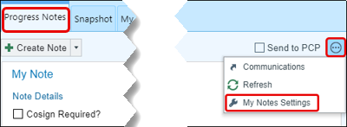
- Click Create New.
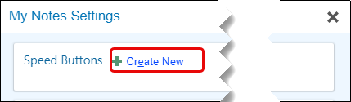
- In the SmartText field, type; LEAP WHA WET PREP.
- Click Accept
- Caption: rename your speed button to something simple (ie: Wet Prep)
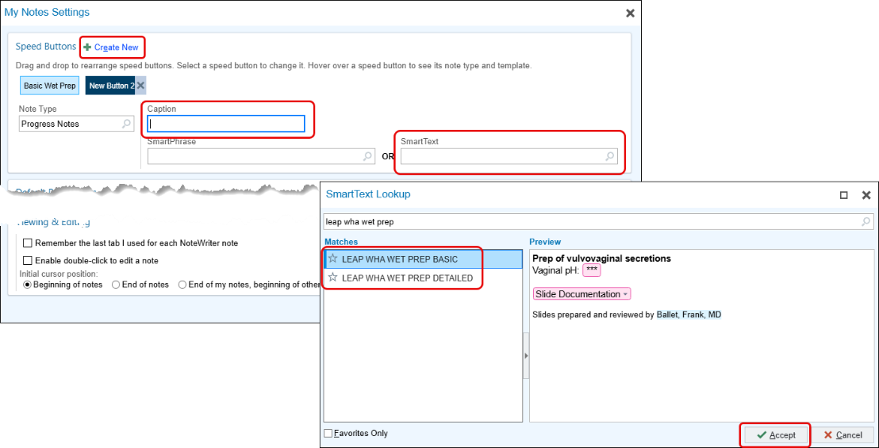
- Repeat steps to continuing adding speed buttons such as:
  - LEAP WHA WET PREP DETAILED
  - WHA OB VISIT
  - WHA GYN VISIT

Orders
Everyone will have need for recurring orders: weekly HCG quants following methotrexate treatment or weekly BPPs for chronic hypertension. Orders should be placed as usual, with a slight adjustment to the timing option (Normal, Standing, Future). The default setting is "Future," since most orders are for one-time procedures scheduled after your visit or following a documented telephone consultation. Best practice is to keep lab orders set to "Future" and only change to "Standing" when applicable.
- Go to the Preference List  located in your visit task bar.
- Select “HCG Quantitative – External” then Accept. Notice the following but let’s focus on Interval and Count.
  - Status: (“Normal, Standing, Future”) see that it is defaulted to Future. Instead, select Standing.
  - Release: Auto is defaulted. Leave this as AUTO
  - Interval: Open this and explore the different options. Set this to Once a Week
  - Count. This is how many times you want to do this. Enter 6.
    - This means Epic will auto release an order for an HCG quant NOW and then weekly thereafter.
  - Expires: Defaults to 9 months but consider how long you’d like this to run. Use your judgement.
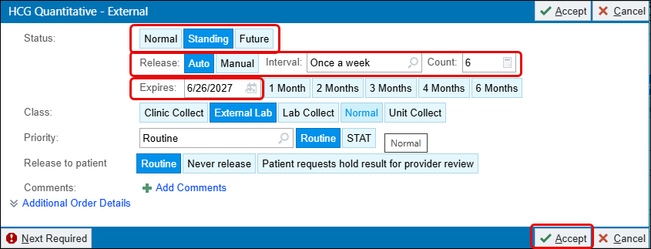
- Click the Star to favorite.

- Change the Display Name.
- Click Accept.
  - Click Yes to “Apply order details from preference list entry to current order?”

Create Your Own Order Panel

Save time searching for orders that you commonly place together, such as a set of labs such as 28 week labs or fertility workp. Instead of searching one-by-one for these orders, create an order panel.
- Within a patient's chart, search for the orders that you would like in the order panel.
- After the orders are queued up for signing, click Create Panel.
- In the Display name field, enter an easy-to-remember name for the panel.
  - Optionally, in the Section field, enter the section of your preference list in which you want this order to appear. Or click New to add another section to your list.
- For routine pregnancy labs, in the Expected Date field, type; GA=28
- If needed, edit the details of each order.
- Click Accept.
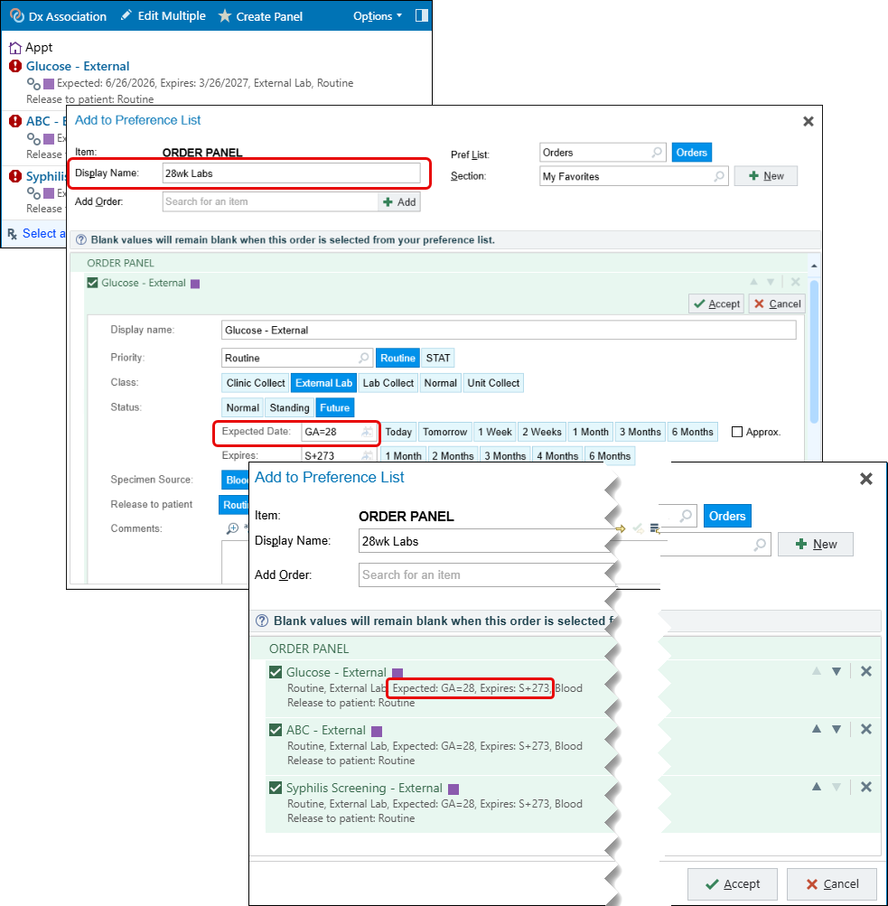
- To use your order panel in a patient's chart, search for the order panel on your preference list by completion matching or browsing, just as you would for an individual order.

After you've created an order panel, you can update order details or remove orders from it. You can also create a copy of the order panel and make updates to it.
- Click in the Visit Taskbar and select the My Favorites check box.
- Right-click the order panel.
  - To edit the current order panel, select Edit Preference List Entry.
  - To create a copy of the order panel, select Add to Preference List and choose a list to put the copy on. 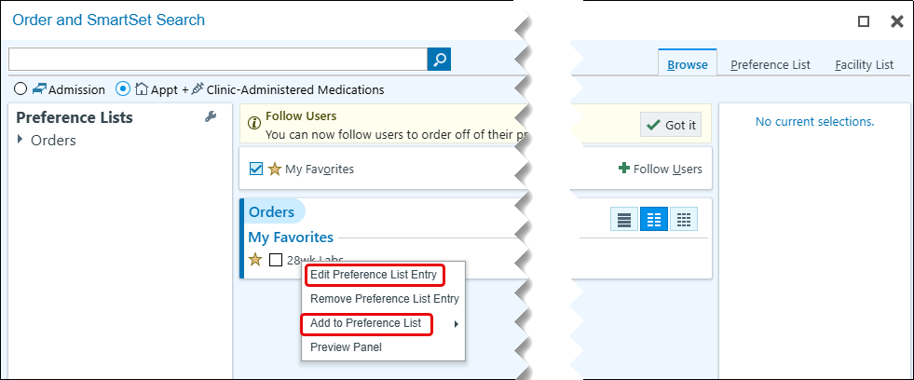
- Repeat these steps for any other order sets that will be applicable.
- Edit order details or remove orders.
  - If you need to add orders, you must create a new order panel.

DON’T SIGN ANY OF THESE ORDERS!!! Let’s move to the last efficiency in orders.

Remember: A Standing order is (clinically) a type of future order, “standing around” ready to be released (automatically by Epic or manually by staff). You want to use a Standing order when you plan to have a recurring order OR you are ordering something way out in the future (more than a month).

Multiple Associate Labs, Referrals and Meds

- BEST WORKFLOW: move a Problem to the Visit Diagnoses or select Visit Diagnoses, THEN order labs, imaging or meds.

It is common to have multiple labs, referrals and meds that all need associating. DON’T CLICK INTO EACH ONE INDIVIDUALLY!

Tasks: Ensure you have a few Visit Diagnoses and a few tests (labs or imaging) entered BUT NOT SIGNED.

- Click DX ASSOCIATION in the top left corner.
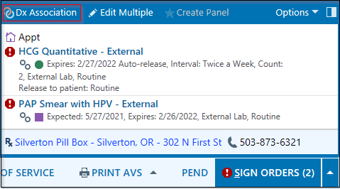
- You should see all the tests and all the diagnoses, and you can select multiple at once!
- NOTE: Labs, order, meds, and referrals will all show up here if you have entered them.
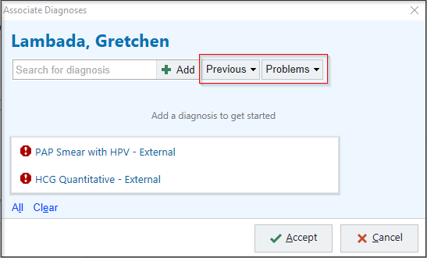

- SECOND BEST WORKFLOW: put your orders in, go back and enter Problems and Visit Diagnoses, then use DX ASSOCIATION.

Remove all of the tests and remove all of the visit diagnoses so they are not still attached to the chart.

Order again in Chart Review

You can quickly reorder a lab, procedure, or imaging order as you're reviewing the patient's chart.
- In Chart Review, select a lab, procedure, or imaging order.
- Right-click the order and select Order Again.
- Choose the order under the Reuse Order Details header to reorder the exact order you're viewing. To use the order details saved in your preference list, choose an option under the From Preference List header.
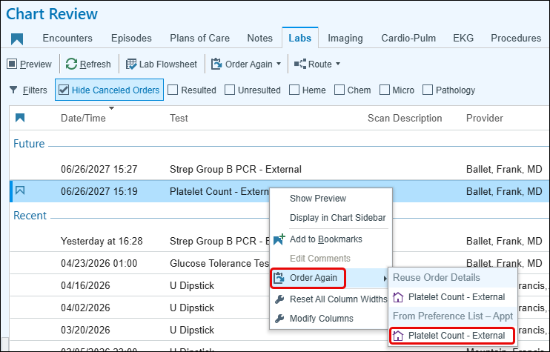

Customizing preference lists
- Open the order search window to the Browse tab.
- When reviewing all the orders available to us, we can see them organized by tab.
  - Browse tab displays all orders in your specialty preference list in a point-and-click format.
  - Preference List tab includes the same orders on the Browse tab, but is designed to be searched rather than browsed
  - Facility list tab is more comprehensive and includes every order available at your facility
  - Database Lookup includes every order possible to place in Epic.
    - Must select the Facility List tab before Database Lookup is available.
    - Should rarely use this tab
- Go back to the Browse tab.
  - Currently viewing all of the orders in your specialty preference list.
  - You can customize this to see your personal preference list instead.
- Select the My Favorites checkbox.
  - This checkbox will be selected every time you open your preference list (until you clear it). You don’t have to select it every time.
  - If you already have some favorite orders, you'll see them here.

Follow a colleague's preference list

- If a colleague in your department or specialty has created a good preference list, you can follow it.
  - This way, you’ll be able to maintain your own separate preference lists and stay up to date with any changes your colleague makes.
  - You can follow up to three colleagues.
- Open the preference list from the Visit Taskbar.
- Click Follow Users from the top of the Orders window.
- Enter the name of the colleague who you would like to follow in the User Search field (ex. Gary Burgoine).
- Select the colleague’s name and click Accept to add that colleague to your preference lists.
- Notice the new preference lists from the toolbar at the top of the Orders window.

WHA SmartSets
SmartSets allow you to address not just relevant orders but enter a progress note, LOS code, follow up, or patient instructions as well. WHA has created some SmartSets for efficiency.

Tasks: This can be done from Quick Tools 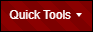 located on your hyperspace bar or can be accessed in an open encounter from the Plan activity. For this activity, you will use your Quick Tools.

- Click the arrow next to Quick Tools.
- Select User SmartSets from the list.
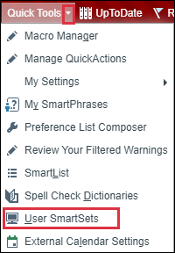

A User SmartSet Selector opens.

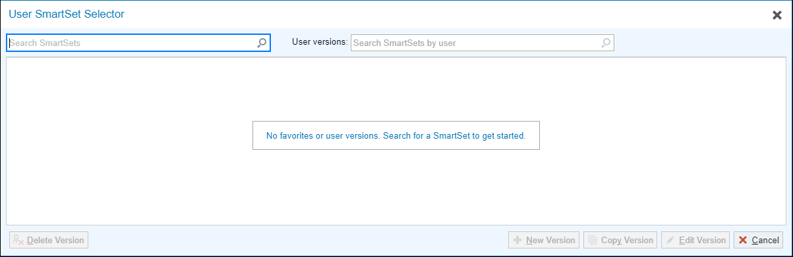
- In the Search bar, type; WHA
- Press Enter on your keyboard.
- Click the star to Add to Favorites.
- Use the magnify glass to preview what’s in the SmartSet.
- When you have added all the desired SmartSets, click the X.

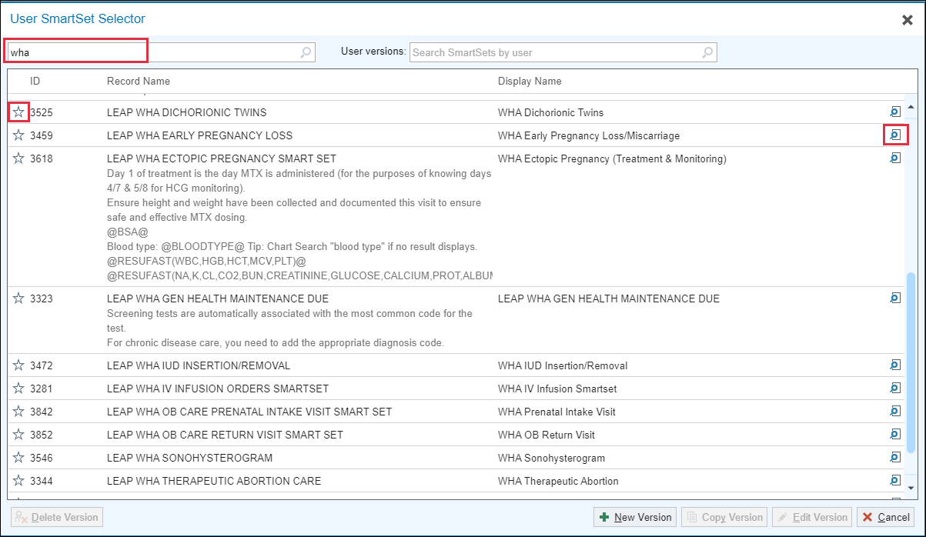

They are now saved under your Favorites.
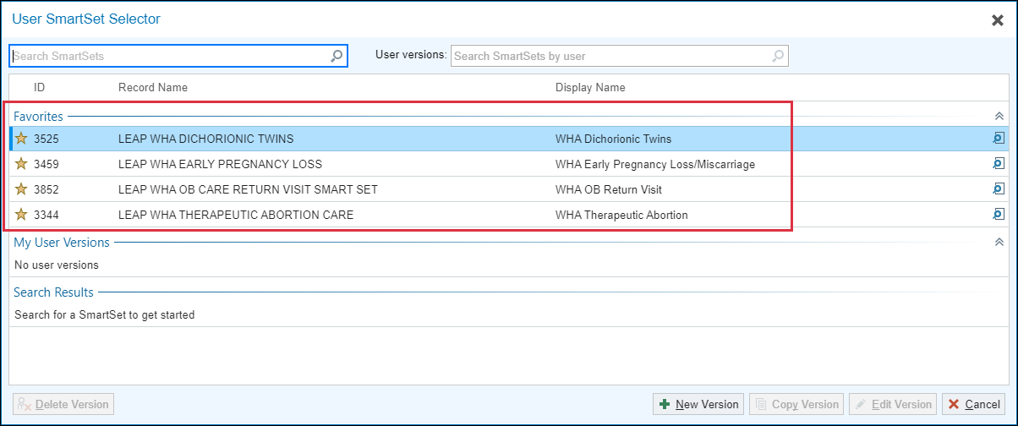

To access your favorites in an open encounter:
- Go to the Plan activity.
- Scroll down to SmartSets.
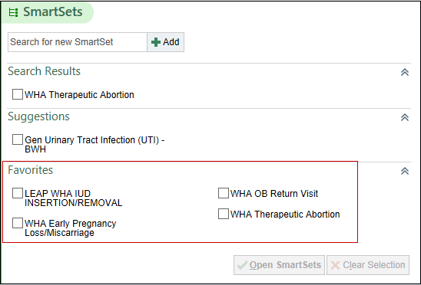

Create your own version of a SmartSet:

- You can create your own versions of SmartSets to save your preferred orders and order details, much like you can with inpatient Order Sets.
- Click Quick Tools > User SmartSets.
- Highlight a SmartSet or use the search bar to find others (ex. AMB OBG Nexplanon Removal/Insertion).
- Click New Version
  - Add a Version nickname.
  - Set any default selections such as a preferred diagnosis or meds. Note: You should not use Lab Orders that are not from a WHA SmartSet or the WHA preference list.
  - Adjust the details of a given order such as a medication sig.
  - Click Save.
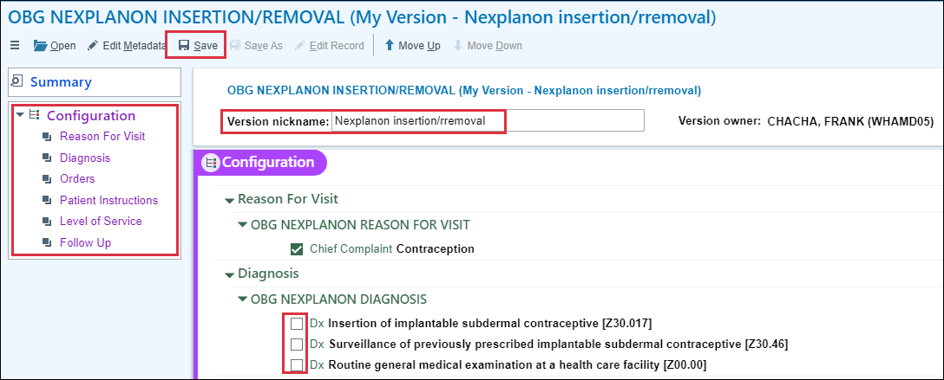

Charge Capture
You may want to favorite some commonly used charges to reduce the need to search for these in future visits.

Tasks: This must be done in an open encounter. Go to your Wrap-Up Activity and scroll to Charge Capture.
- ClickAdd.
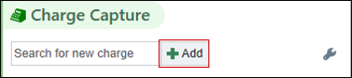
- In the Search bar, type; non stress test or [59025] and press Enter using your keyboard.
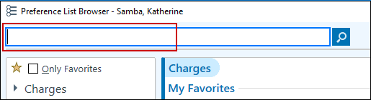
- Right click on the procedure, hover on Add to Preference List and click Charges.
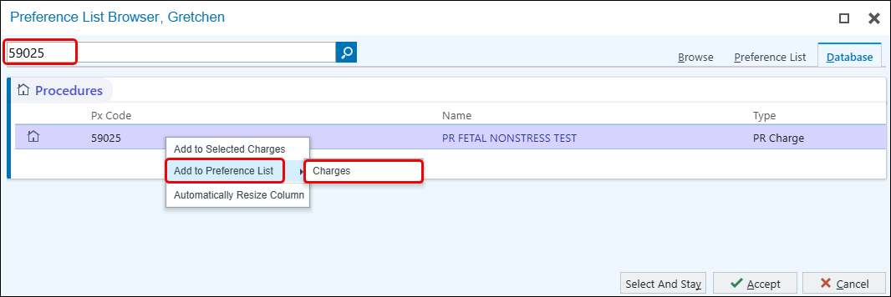
- Give it a name, then Accept.
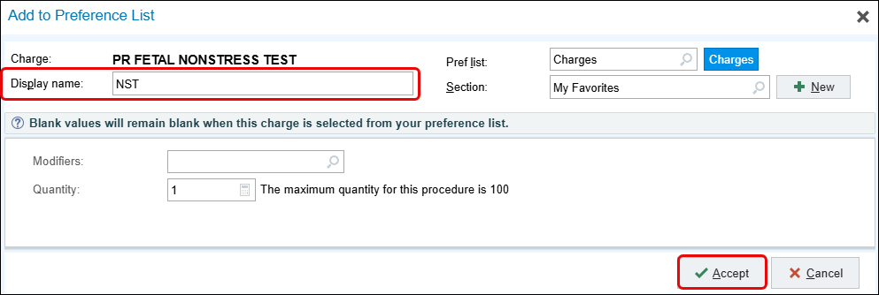
- Click Cancel.
Repeat these steps for the other add additional charges.

Other clinic charges you may want to consider adding:
- Performing SIS (58340)
- SIS U/S Reader (76831)
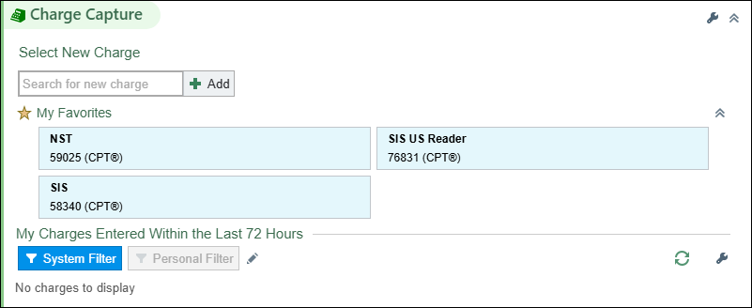
- Use the Wrench in this section to change your speed buttons to checkboxes if you prefer a different style.
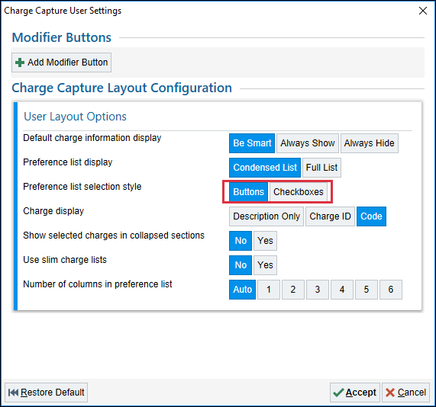

Level of Service Speed Buttons: How to change and/or add

These steps are provided for example purposes only. There is no need to modify the set speed buttons unless you wish to do so.

- Click on Level of Service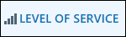 located in your visit task bar.

The Level of Service window opens
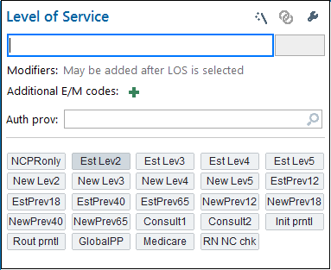
- Click the wrench located in the upper right corner.

You are now able to edit your speed buttons.
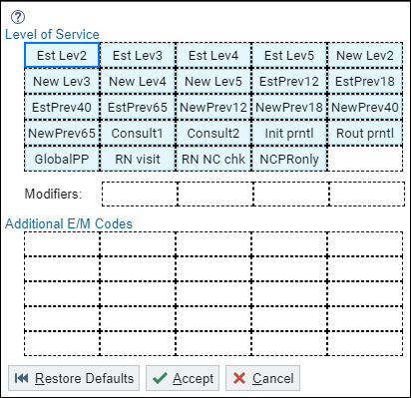
- Hover over the RN visit speed button to see the pencil to remove this option from your list. (you may also choose to remove RN NC chk)
- To add a Speed Button, go to a blank box and clickAdd.
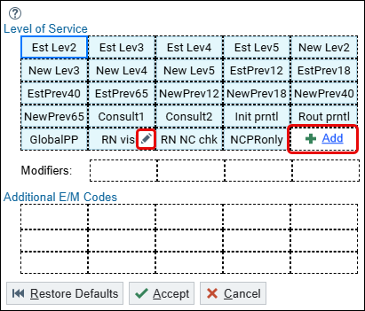

Additional E/M codes may be added as necessary if a wellness visit includes the assessment and management of additional problems during the same encounter.

- Click on the Add under Additional E/M Codes.
- The Button Editor widow opens.
- Click in the Caption search box, type; MDM 20 min, press Enter.
- Click in the Level of service search box, type; 99213, press Enter.
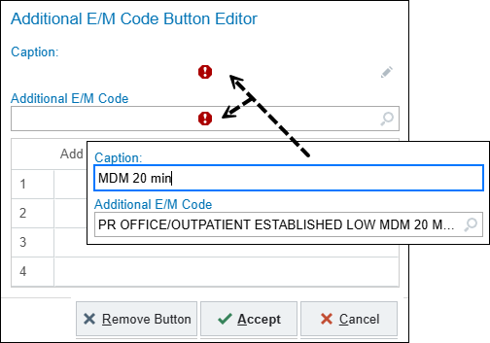
- Click Accept.
You have successfully created a new speed button.
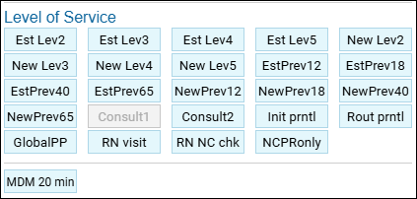

Referrals

If you need to verify whether a referral has already been placed for a patient, this is where you look. To send it to another person (or outside organization), you will want to go to the Other Orders activity.

Exercise 3: SmartPhrases and Macros
Use this opportunity to clean up, steal others, or build your own SmartPhrases and macros.

SmartPhrases
Use the green plus sign to create a new smartphrase or the magnify glass to look up and take another individual’s smartphrase’ s. Remember to use ‘naming conventions’ when creating SmartPhrases to make them easier to find and use.

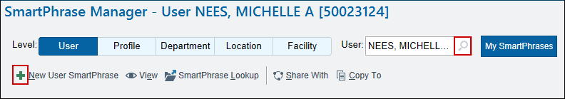

SmartPhrases, also referred to as dot phrases, can be managed and created in a number of ways. They’re helpful to save time while documenting commonly typed phrases, or to help spell words correctly.

Naming Convention

.initials | where it goes in the chart | abbreviated description
.WHA | AP | WWE1834

Start the Smartphrase with your initials, this will make it the easiest to remember.
- Avoid starting a Smartphrase with WHA or your site name.

Then, where it will go in the chart.
Example: HPI or PI for patient instructions

Lastly, you’ll type an abbreviated description. In the example above I used WWE1834 which would be for a Well Woman Exam ages 18 to 34.
- Note: You cannot use dashes in the Smartphrase name.

The description box below is where you can expand and add details on what is included in the Smartphrase. This allows you to keep the smartphrase name short.

As you type .WHAHPI in the HPI area of the chart, it will pull in a list of all of the smart phrases that start with that naming (descriptions included), which makes it easier to find what you need. Following this naming convention will do the same to help you keep your smartphrase organized and easy to access. See example.

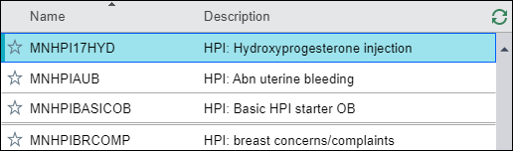

How to create copies of other users’ SmartPhrases

The phrases that have been shared with you by other people, you may not be able to edit. To create a phrase that has the same content but is able to be edited by you is quite a bit easier now than it used to be.
- Click SmartPhrase Manager from the hyperspace toolbar.
- In your SmartPhrase Manager, find the user box. It will have your name in it.
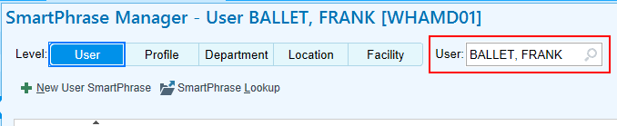

- Type the name to the person you are looking to create the copy from and press enter.
- Gregory Eppard
- Colleagues from your site
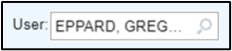
- In the Search box 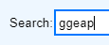 on the far-right side of the screen
type: GGEAP
- Find the smartphrase: GGEAPAUB
- Double click on the smartphrase.
- It will show up as grayed out, showing you that you’re unable to edit it. In the bottom right corner of the screen, click Create Copy.
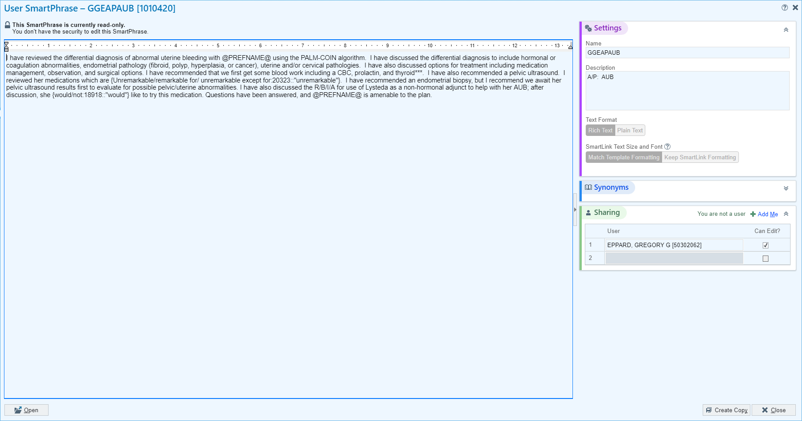

- Enter a new name for the SmartPhrase. Use the naming convention described above.
- Click Accept.
- Once the SmartPhrase is edited to perfection, click Accept again in the bottom right corner of the screen to save it as your own SmartPhrase.

Macros

Best Practice when creating macros is to use a ‘stack’ technique. This will be talked about a bit more as you go through this section.
- Click Quick Tools
- Click Macro Manager
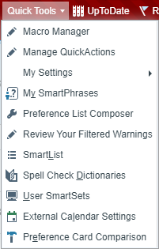

If you have previously created Macro’s, you will see them listed here. Below will focus on these three things:

- Change or delete current Macro’s.
- Create New Macro’s.
- Browse Macro’s by User.
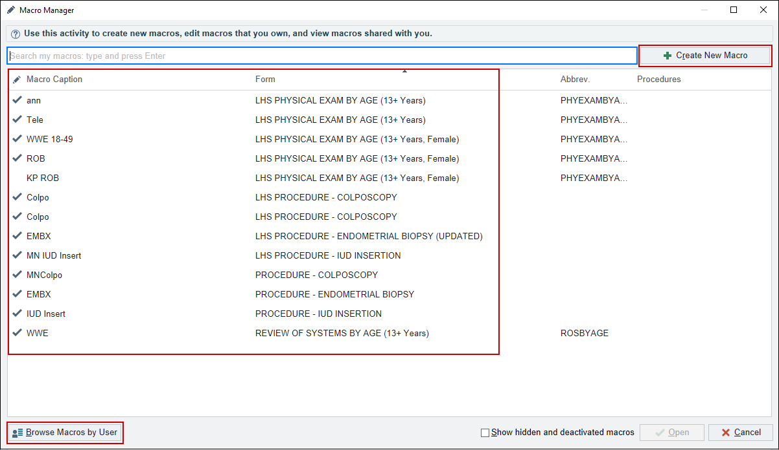

Change or delete macro’s you created:

- Clicking on the macro to highlight/select.
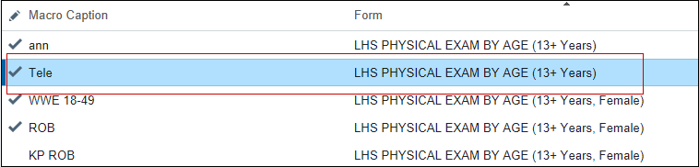
- Click Open .

You can now make changes to this macro.

- Notice in the top banner that you also have assess to all the physical exam macros that you created so you can make changes to mutiple ones. Simple click on another macro that you wish to change.
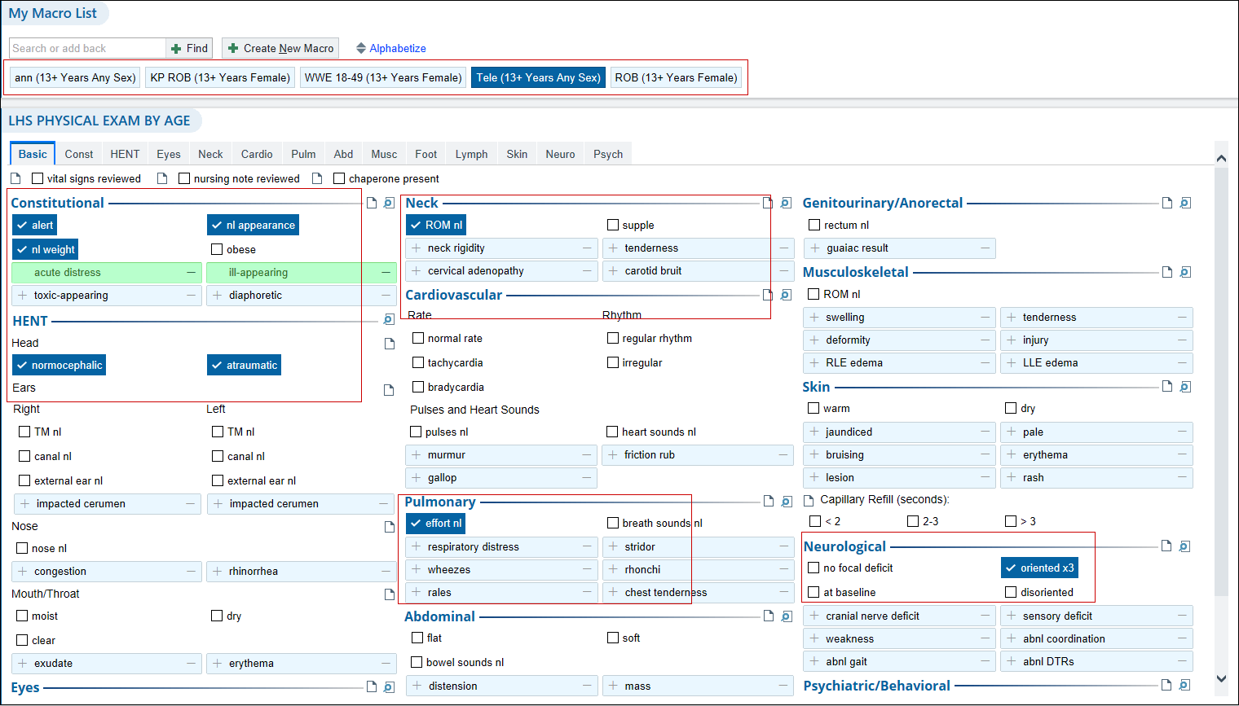
- Click the X next on any macro you wish to delete when you hover your mouse over the macro.
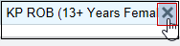
- Make sure to Save as you go so you don’t lose any changes.
- Click Open a List of Macros to return to your original list should you wish to continue making changes to ROS or Procedure macros.
- Click Accept when complete will automatically close your Macro Manage tool.

How to create a new macro using this tool
- Click Create New Macro located in the upper right corner.
- Name your macro.
- Choose what NoteWriter SmartBlock you want to create. For this example, I will use the LHS PHYSICAL BY AGE.
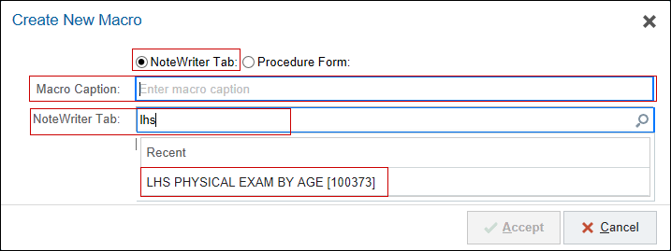
- Age: 13+.
- Sex: Female
- Click Accept when compete.
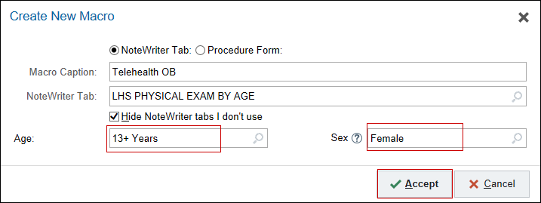
- You now have a blank form to add the information needed.
- Best Practice when creating macros for wellness visits is to ‘stack’ these macros. Create one for Basic, one for Breast, one for GU, etc…
  - When you create a macro that has all these forms in one macro, there is generally more clicking involved. There is also a greater risk of forgetting to update a tab with abnormal finds should you get interrupted or are having to chart at a later time. You want to avoid having HPI documentation conflict with what you have documented in your PE.
- Click the Procedure Form SmartBlock to create macros for procedures.
- Name you macro.
- Type: Procedure and scroll through to find what you’re looking for.

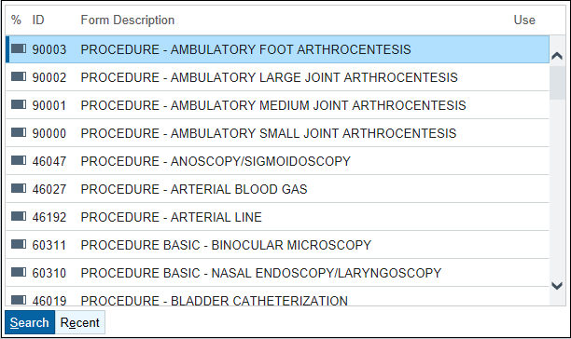
- Click Accept.
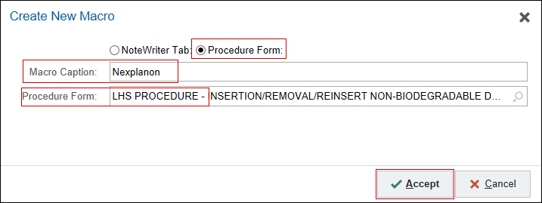
The procedure form opens and you can begin adding your documentation.
- Be sure to click Save as you go.
- Click Create New Macro if you want to create multiples of the same procedure. (Ex: Nexplanon Insertion/Nexplanon Removal).
- Click Open a List of Macros to return to your original list should you wish to create a different Procedure macro.
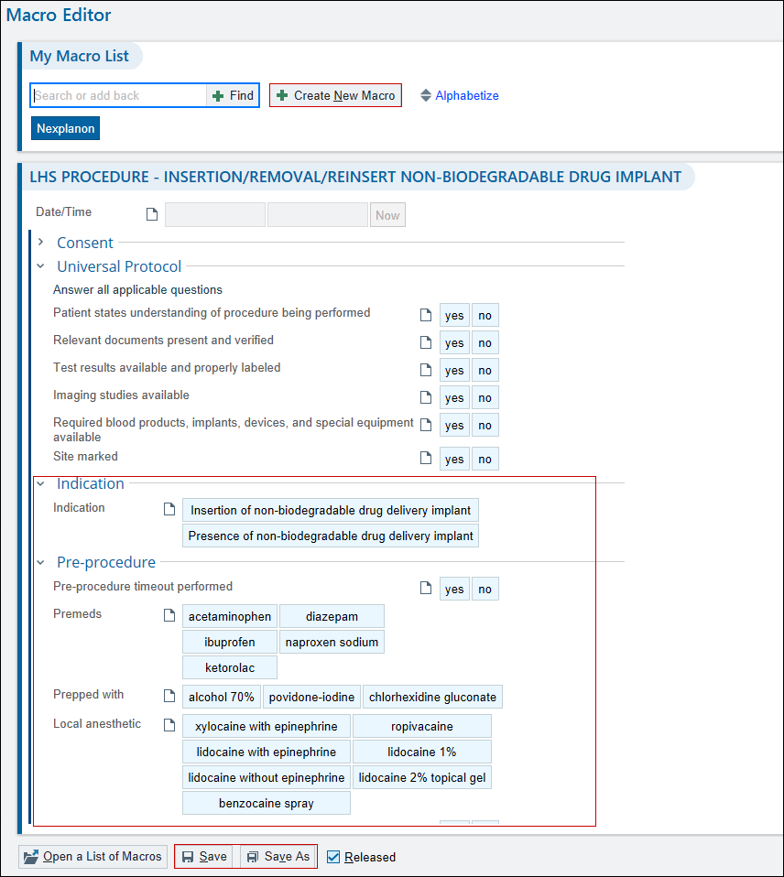

How to see or take your colleague’s Macros

This functions much like searching and taking other users Smartphrase’
- Click Browse Macros by User .
- Type in a user name in the search box. For this example I used Dr. Bell but Dr. Burgoine has some good ones as well.
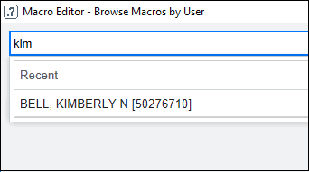
- Click the green plus to add the user’s individual macros to yours.
- Click the Add Me to All button if you want them all.
  - Note: that you can only view what’s in the macro once you have added it to yours.
- When you add yourself to another user’s macros, if they make changes to their macro, it will update the macro you added yourself to as well.
- To make changes to another user’s macro once you have added it to yours, you must click Save As and rename the macro before you can make any changes.
- Be sure to remove the original macro from Dr. Bell if you have done a Save As.
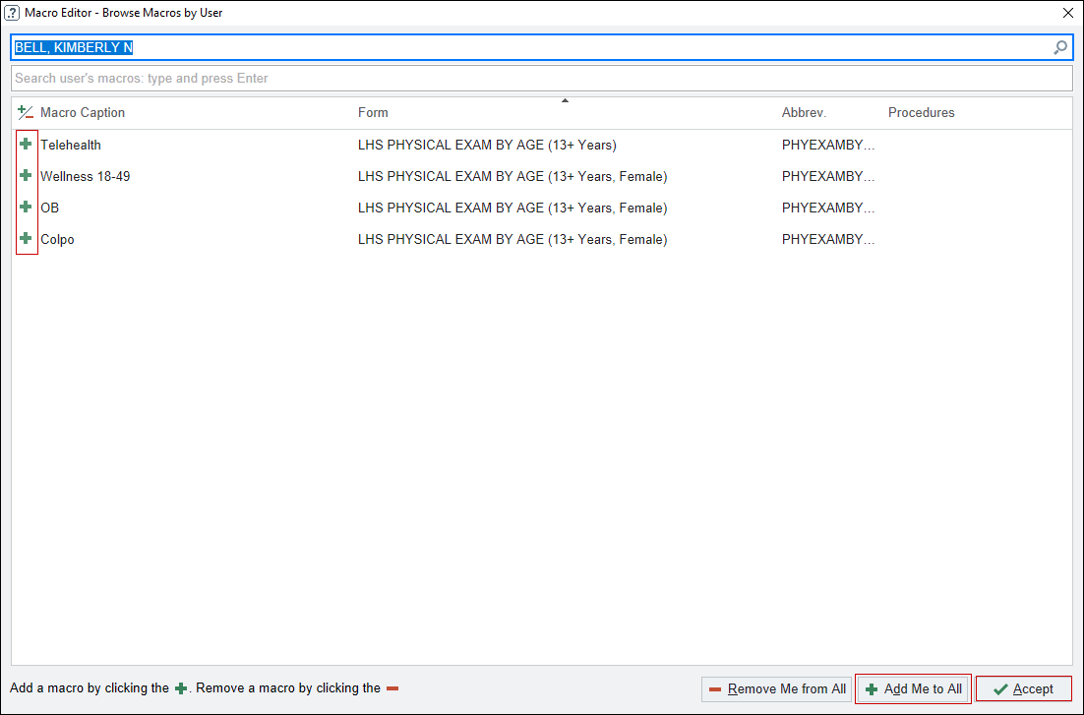
Take time now during customization to get a head start on building macros or you can simply wait until you are in clinic seeing patients so you have a better idea of what you might want.

Care Everywhere

What Lives Where and Arranging Reports for Efficiency
Care Everywhere is set to query local/regional Care Everywhere enabled systems, but you can also search for organizations/systems nationwide (more on that later). Interoperability between Epic instances with Care Everywhere is also the vehicle that allows reconciliation of Problems.

Tasks: From within Legacy Epic: choose a WHA patient who delivered or was operated on at a Providence facility.

- Home (Overview). This shows the different organizations that have information available to view. If the patient is not fully registered in the system (aka is missing a SSN) or is using a different last name (or part of a last name, especially without a SSN) then nothing may show up here. This tab shows you what types of information are available from each organization. Less information is available from non-Epic organizations (usually only labs).
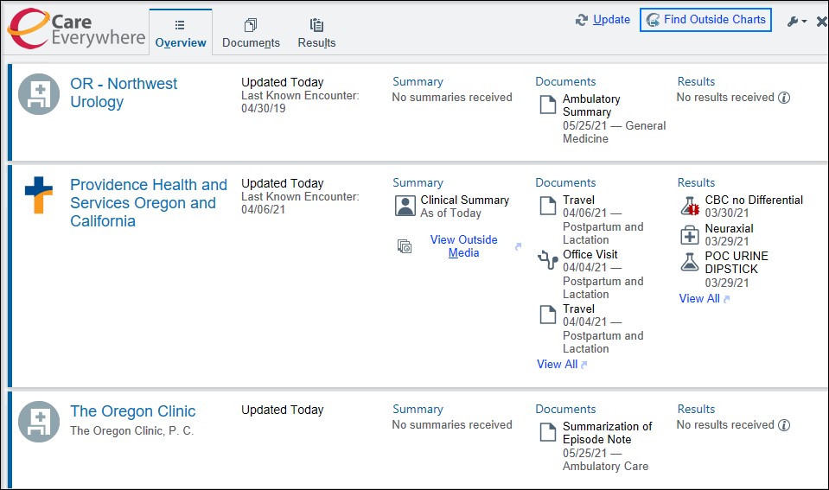
- Summary. This is the best place to review the patient’s history quickly.
- From Summary 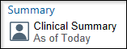 tab. Go to the wrench in the right corner, next to “Jump to Section”.
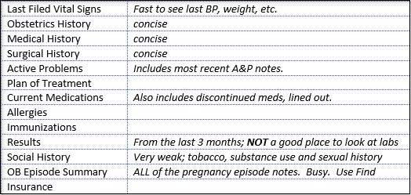
Customizing the Favorites and arranging the information in a clinically logical format.
If your “Favorites” are empty (likely, if you have never tinkered with this) you will have to go to “Available Sections” and push the favorite stars to get them into the “Favorites” section. Once in the “Favorites” list, you drag and drop the items. When you’ve got them in this order, click Accept.
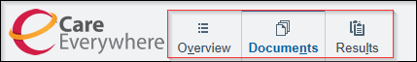
- Documents. This is where to go to find delivery information. The filters (OP Visit, Office Visit, Telephone, ED, and Lactation Encounter can help you sort through the enormous number of documents. Admission and Surgery are usually clearly labeled. Use “Review Document” to download. Don’t change or edit the filters.
- Lab Results. This is the best place to look for any labs including OB labs. Labs are consistently labeled, discrete and show all results over time. It can be best to use the alphabetical discrete list in the lower left column.
- Other Results. This is best thought of as Imaging. However, sometimes you will see Cardiopulmonary and Anesthesia notes here; it can be a little random.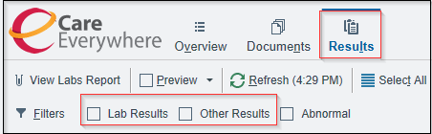

Exercise 4: InBasket and other Tools:

Granting Access and Attaching to your Partner’s In Baskets

You will need to address results or issues from your colleagues’ In Basket eventually. While many things can sit in someone’s In Basket for a business day or two, there are instances where a lab needs more expedient management or your Advice team asks you to weigh-in on an issue. We also need to be able to cover for our partners when they are on PTO.

In order to easily access your partner’s In Basket, there are two steps: Granting Access to all of your (sites) partners, your MA(s) and Advice (RNs) colleagues and Attach those partners you most often/closely work with (in your Pod). There is no way to Attach to a Pool.

Tasks: Go to your In Basket.

- Grant Access. On the In Basket activity bar, go to Attach (Attach Other InBasket) and then go to the second tab “2 Grant Access” (Grant users’ access to My Messages).
  - Enter the names of all your MD, CNM and NP partners, the MAs in your Pod and Advice RNs if you desire.

- Attach. After you have completed step 1, then go back to tab “1 General” (Persistent Attachments).
  - Enter the names of the clinicians in your Call group (minimum; you can enter all of your partners if you wish).

Review how this looks on the In Basket. See the list of attached clinicians on right side of desktop. On the left, see how there is an additional (collapsing) folder called “Attached & Covering Users”. You can control how many attached clinicians “Show” by from Attach, Grant Access and using the Show check boxes for individuals, controlling how many people persistently show in your In Basket. Some people may want this in order to avoid clutter.
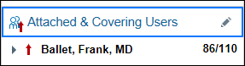
MyHealth Utilities and Quick Actions (focus on PAP/HPV and OB labs).
There are four main types of In Basket responses that clinicians will use to deal with Results:
- Result Release
- Result Note
- Telephone Call
- Letter.

The best practice is to use MyHealth capable actions (Result Mgmt) whenever possible (can add orders, referrals, facilitate involvement of MA or RN call for scheduling) and a Telephone Call if you call the patient (to discuss pathology or complex/abnormal results).

CRITICAL: Result Mgmt are set to attach ALL, NONE, or ABNORMAL results. PAPs and path are not discrete data but text and therefore cannot be recognized as ABNORMAL. For text results, build QuickAction with NONE set to attach: Epic will prompt you to Select Orders (the results) you want when you use the Result Mgmt. If you use ALL, everything that returned on that date will be selected and you may include other results in your note (not what you intend).

Tasks: Go to your InBasket and pull up a PAP (if one is available).
- PAP and HPV results. Review the built-in Chart Review actions. See that there is a Result button so you can get to the baseline In Basket view/appearance.
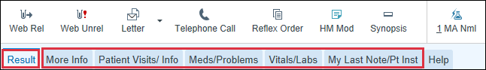
  - More Info. Cervical Cancer Screening History – Results and Follow ups is at the bottom. The Result Date hyperlinks pull up the actual PAP result. The Tests and Procedures tells you what the order was and the hyperlink will launch PAP Tracker (which is for Abnormal results). If the patient is in Management and Pap Tracker has been used, the Follow-ups will show the next action that was entered.
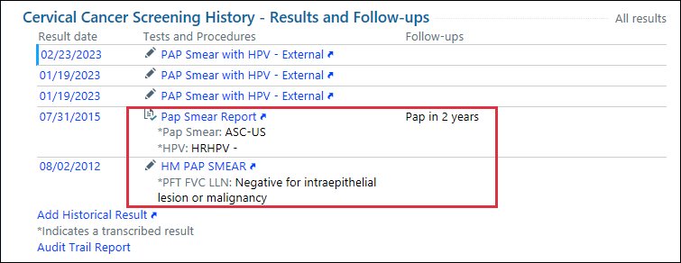
  - Patient Visits/Info will show you what their recent visits (which can help you remember if this is a Screening PAP from a Wellness Visit or if the last visit was a Colpo. It will also show Future Appointments if the patient has any scheduled.
  - Meds/Problems will display current Problems and the last A/P from Problem Based Charting. You can view current Medications, Allergies and Upcoming Health Maintenance.
  - Vitals/Labs. Scroll down Recent Lab Results. Here you will see Gyn LC Report, High Risk HPV, HPV source, Pap Smear and if you hover, you can see the detailed reports.
  - My Last Note/Pt Inst. Another way to figure out how to disposition this PAP.

- REMEMBER: other sources of info are the GYN HISTORY SUMMARY (Ctrl-Spacebar), the CCS Snapshot or the Cervical Cancer Screening in the patients Storyboard.

Build Lists of Recipients
If you often send notes, results, letters, or addenda to the same individuals, consider saving their contact information in distribution lists called My Lists. This allows you to efficiently add multiple recipients to your messages with just a few clicks. For example, your results My List could include a colleague, support staff and department nurses, while your Letters My List could include the support staff who edit and send your letters.
- Open an activity where you send messages to colleagues. For example, open a Patient Call message in your In Basket and click Reply. Or open a telephone encounter and go to the Routing section.
- Click to the right of My List and select Build My Lists.
- If needed, update the type of message you want to build a My List for on the left side of the window that appears.
- Enter your preferred recipients for this type of message in the field on the right. To add a pool, such as your department's nurses, enter p followed by a space and the name of the pool.
- Click Accept to save your list.
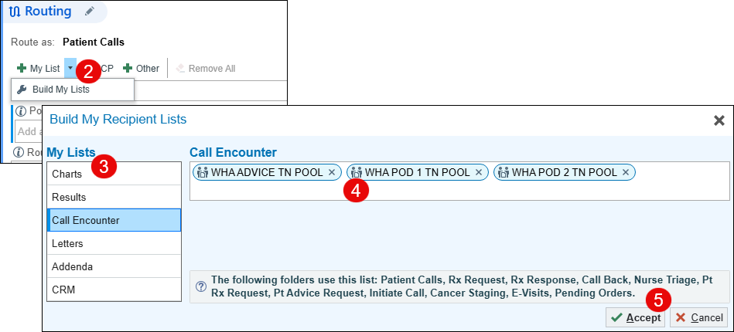
To build your My List for Staff Messages, you’ll need to do that work from a QuickAction.
- From your InBasket, clicknext to New Message and select Create New Message QuickAction.
- Click to open recipient entry.
- Enter your preferred recipients for this type of message using the fields on the left. To add a pool, such as your support staff, department's nurses, etc. enter p followed by a space, WHA then space and the name of the pool.
- Click the Add ‘To’ button for each recipient you wish to include.
- Click Accept to save your list.
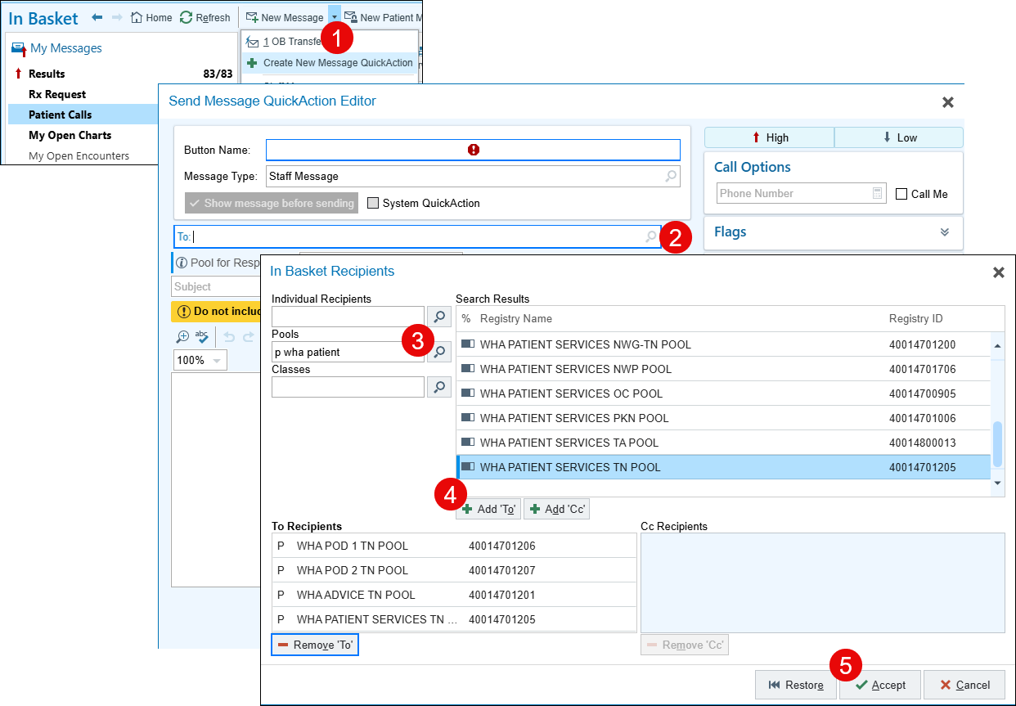

To use the My List when sending a message:
- Click the arrow next to the My List button to select a specific recipient from the list. To add only a few recipients from the list, select each one using the arrow button.
- You can add your recipients as quick access buttons or continue to build on your list from here.
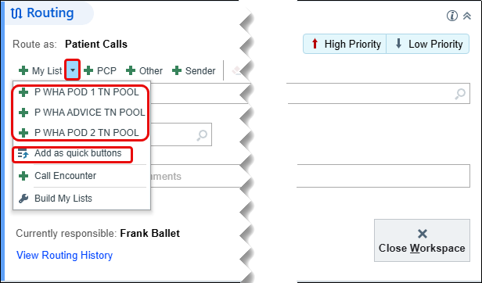
- For Staff messages, simply click on To: and select one or more recipients from the list.
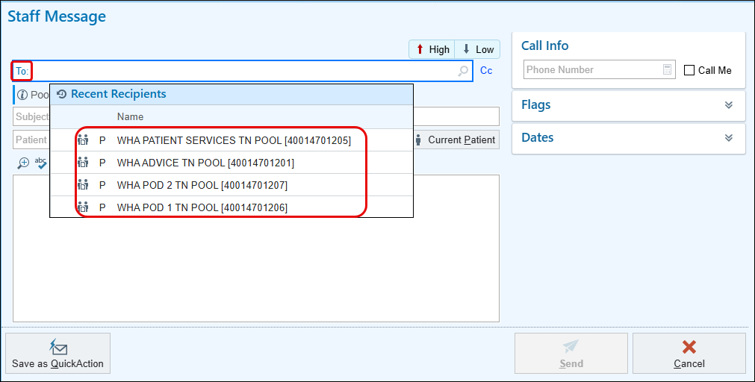

Result Management (Mgmt)

CCS Negative. Create a rapid way to notify a patient of her negative PAP results if she is Active on MyHealth. Use Manage QuickActions to select a Result Mgmt (use the carrot/down arrow.

Let’s set up a Quick Action for a normal pap
- New QuickAction (Result Note) if you go to the folder.
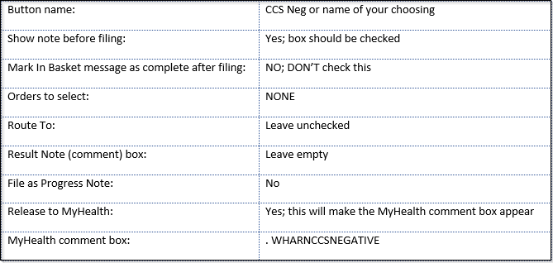
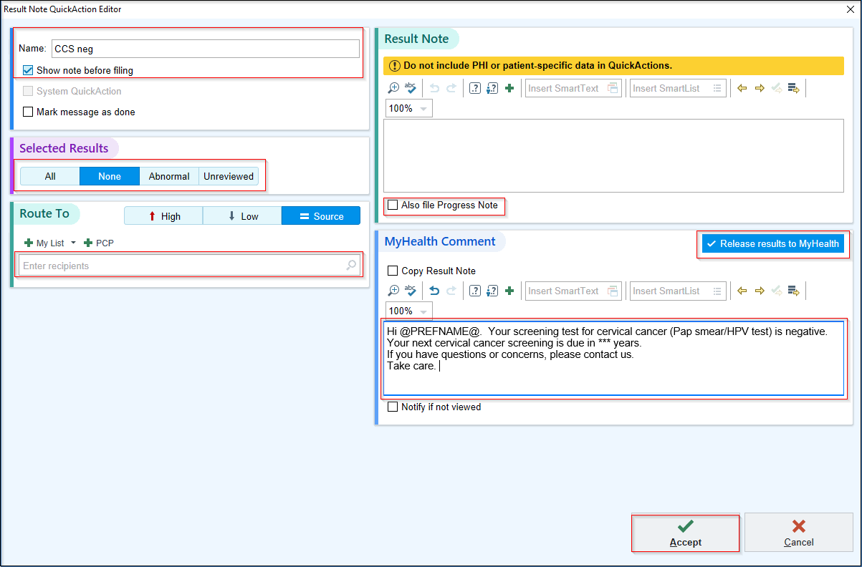
Click Accept to save. It should now appear as a button down on the lower Results bar.
- Result Note: Colpo Needed. (If a patient doesn’t have a MyHealth account, this still works!). Use Manage QuickActions to select a Result Note (use the carrot/down arrow or use New QuickAction (Result Note) if you go to the folder).
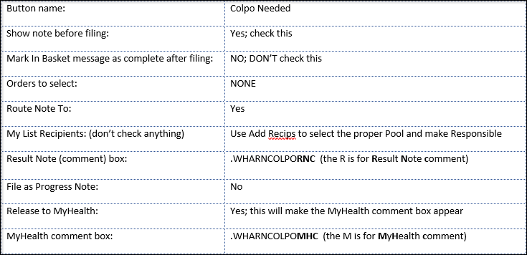
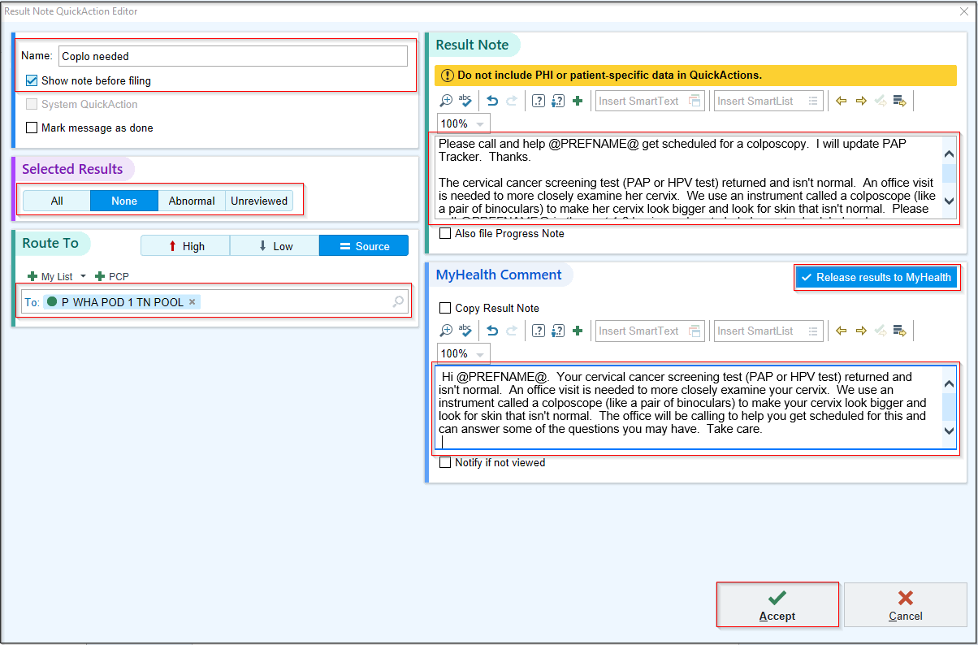
Click Accept to save. It should now appear as a button down on the lower Results bar.
- Result Note: LEEP Needed. Use Manage QuickActions to select a Result Note (use the carrot/down arrow or use New QuickAction (Result Note) if you go to the folder).
- EDIT THE RESULT NOTE AND MYHEALTH NOTES TO REFLECT YOUR SITE/PREFERENCES ABOUT USING IOS.
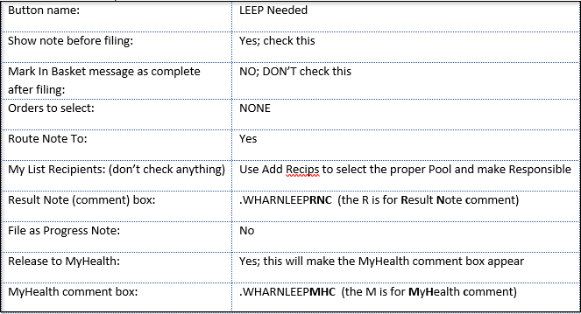
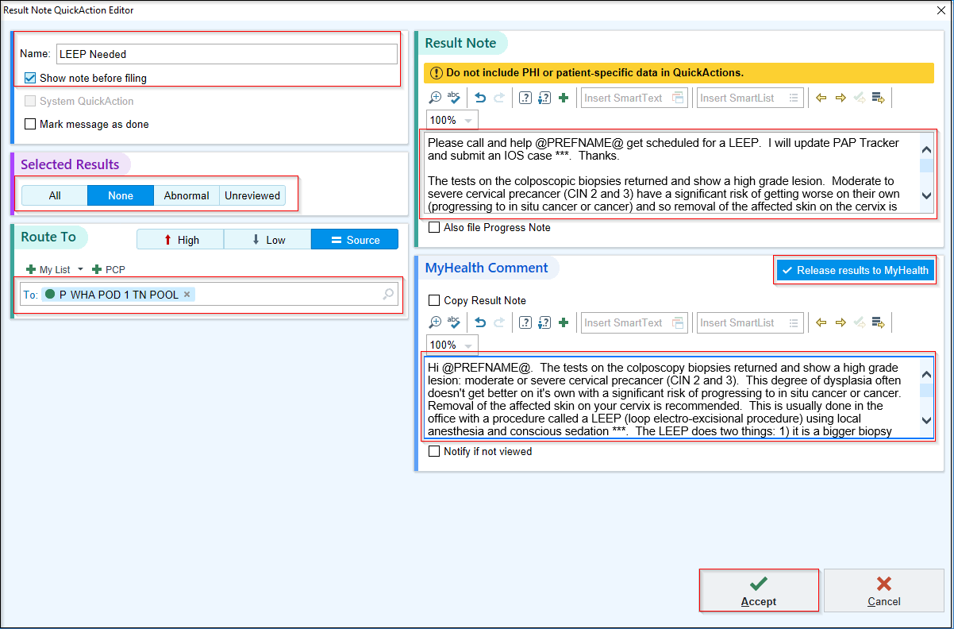
Click Accept to save. It should now appear as a button down on the lower Results bar.
- Result Note: 1hr GTT Abnormal. Use Manage QuickActions to select a Result Note (use the carrot/down arrow or use New QuickAction (Result Note) if you go to the folder).
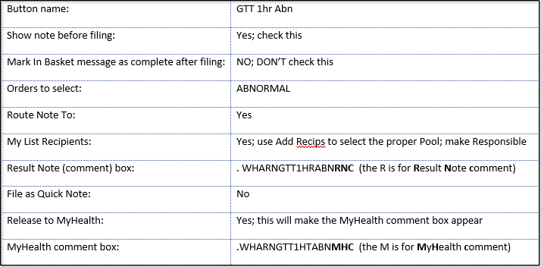
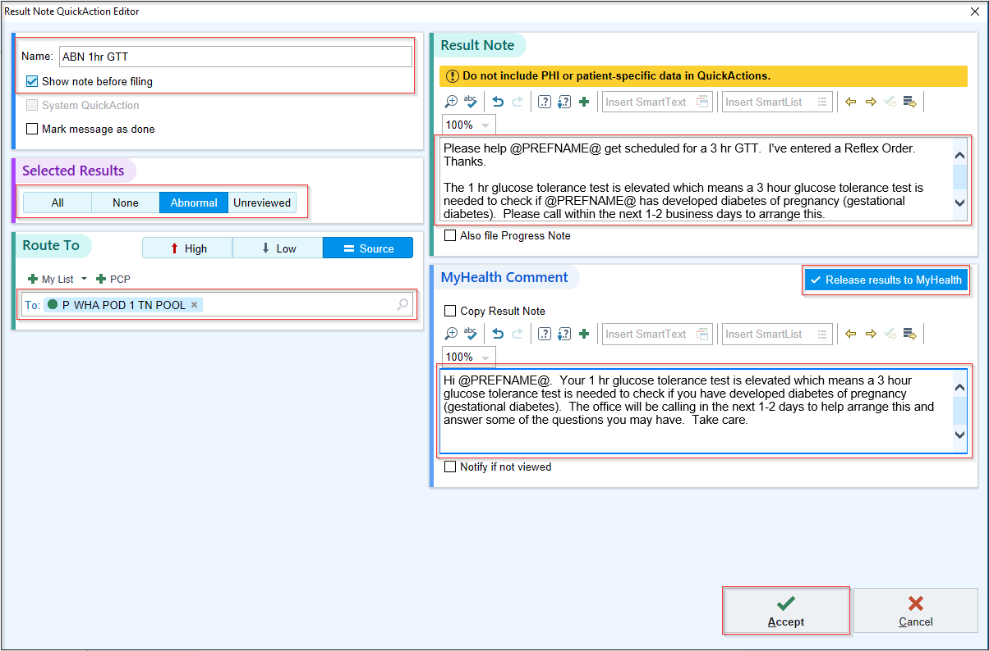
Click Accept to save. It should now appear as a button on the lower Results bar.
- Result Note: 3hr GTT Abnormal. Same as above except pull in two difference Smart Phrases (below).
Button name: | GTT 3hr Abn
Orders to select: | ABNORMAL
Result Note (comment) box: | .WHARNGTT3HRABNRNC (the R is for Result Note comment)
MyHealth comment box: | .WHARNGTT3HRABNMHC (the M is for MyHealth comment)

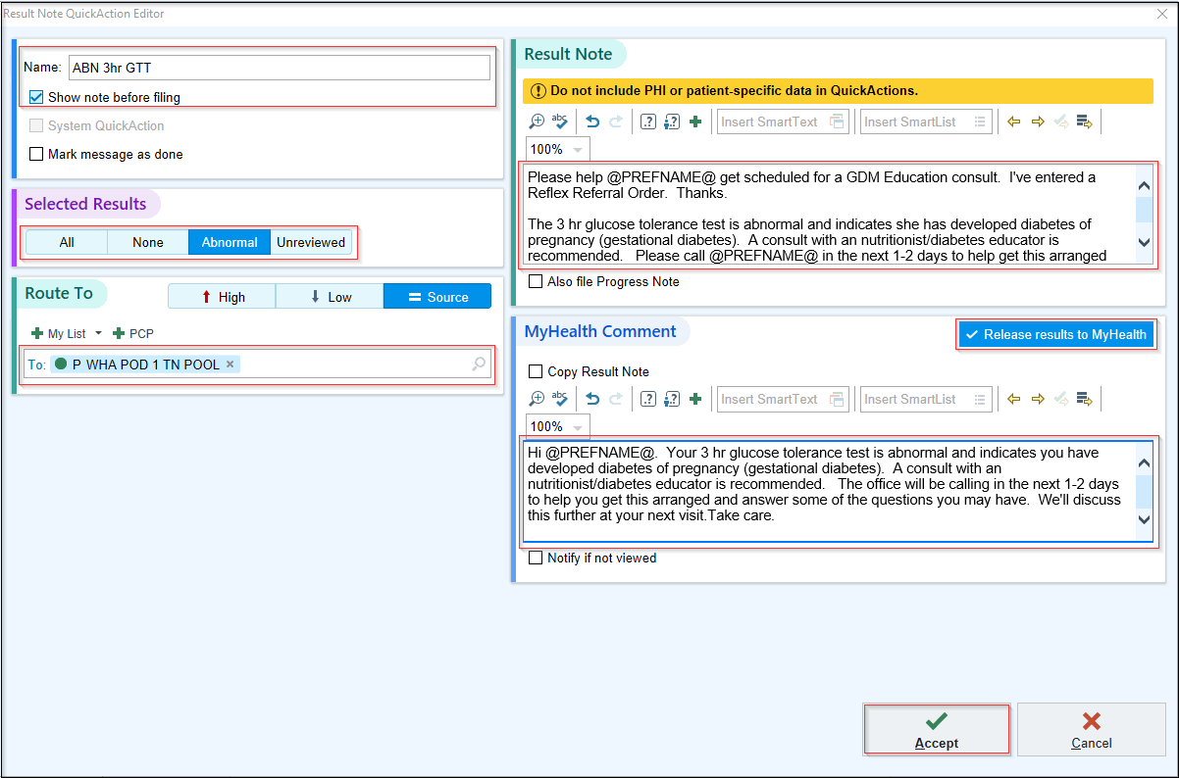

Click Accept to save. It should now appear as a button on the lower Results bar.

Send (Staff) Message QuickActions

Task: Let’s make a few Send Message QuickActions: Appointments, IUD follow up, inductions. Only add ones you think might be useful. You can always add to this once you get settled a bit more in the clinic.
- Choose Send Message for the Hyperspace bar. If it’s not there, you may need to wrench it in (EPIC>Patient Care).
- Click “Save As QuickAction” to bring up the editor.

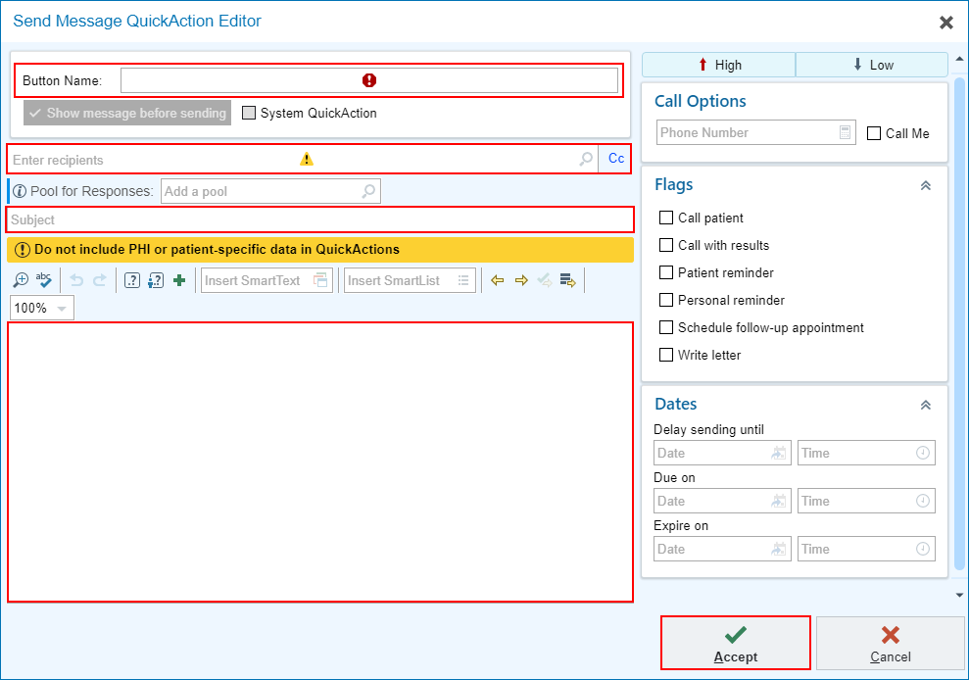
    - Button Name: Appointment
    - Enter recipients: add Pod Pool (e.g.: P WHA PATIENT SERVICES TN POOL). You can also enter: P WHA your location and see a list.
    - Subject: Patient needs appointment
    - Notes: Please call .PREFNAME to schedule her for a *** visit ***.
    - Priority: Routine (don’t click High or Low buttons)
    - Dates: Leave this blank
    - Accept.
  - Repeat steps: Induction This way, you can access it quickly to notify the surgery schedulers of the hospital procedure you need to have scheduled.
    - Button Name: Induction
    - Enter Recipient: Add the appropriate Pod Pool (e.g. P WHA Surgery Scheduler Pool).
    - Subject: Hospital Induction
    - Notes: Add your induction smartphrase if you have one, otherwise type a generic note.
    - Priority: Routine or urgent
    - Date: Leave this blank
    - Accept.
  - Repeat and make a follow up call message. Notice the different “Send on” parameter. This way, you send it the day you do it and the MA pool gets it a month after the IUD insertion.
    - Button Name: Follow up Call
    - Enter Recipient: Add the appropriate Pod Pool (e.g. P WHA POD TN POOL).
    - Subject: follow up call 1 month after…
    - Notes: Please contact .PREFNAME (MyHealth Message preferred) and check to make sure she’s doing ok with her new IUD.
    - Priority: Routine
    - Date: M+1
    - Accept.
Now navigate to the additional tools arrow, hover over Send Message and you will see all the QuickActions you have made.
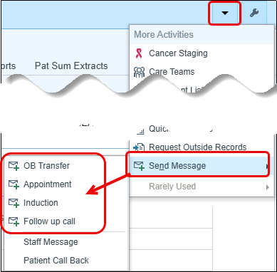

Preference List Composer

You can view and organize your own or take your partner’s preference list.
- Click My Tools on the main toolbar and open the Preference List Composer.
  - Can also search for the Preference List Composer in Chart Search
- By default, all orders are saved to the “Orders (Outpatient)” list.
- Double-click the Orders (Outpatient) list to edit it.
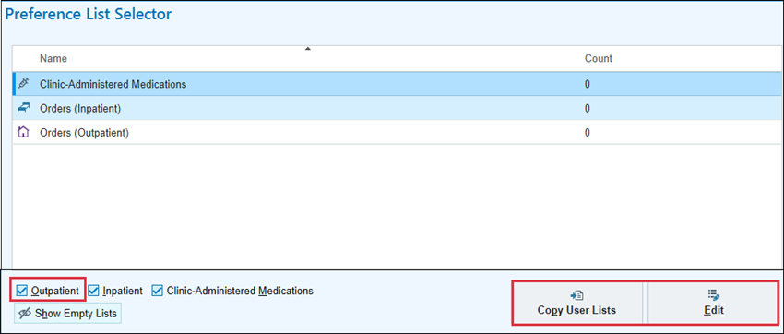
- Create a new section (ex. Referrals).
- Add orders and move an order to a different section.
  - Can use the search bar to see if you’ve already saved a particular order.
- Can organize your preference list whatever way makes most sense to you.
  - Could create sections for the top ten common conditions or diseases you might see a patient for and add the orders you typically need for that kind of patient.
  - Could organize sections by type of order (ex. pain meds, internal labs versus external labs, etc.).

Note: When taking a colleague’s preference list, you cannot view what they have listed until you copy it to yours so use caution to avoid ending up with a lot of things you don’t want.
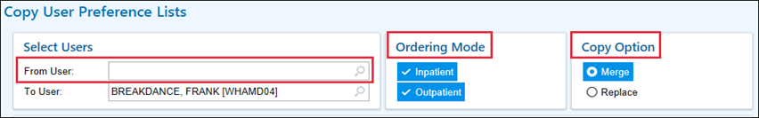
Grabbing the IP charges that Greg Eppard has already built, will make it easier to send your charges through Haiku. If you have not met with Greg Eppard yet, let’s add those charges so you are ahead of the game.

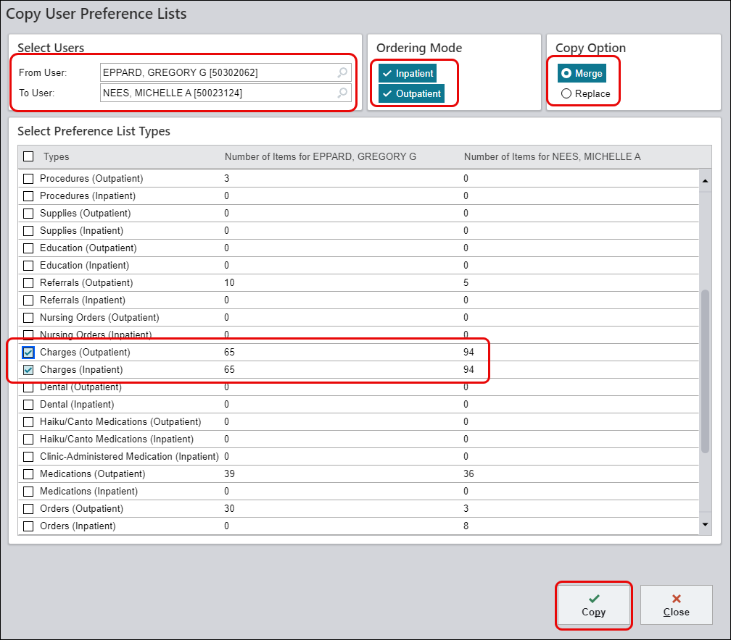
Retrieving the IP charges that Greg Eppard has already put together will make it easier to submit your charges through Haiku. If you haven't met with Greg yet, let's add those charges now to ensure you are prepared ahead of time.
Once you have copied someone’s list, you can then go through it and reorganize, create new sections/subsections, change, rename or remove an item completely.

Preference List Editor

The Preference List Editor is used to customize your non-orders preference list including reasons and diagnoses.
There is no functional difference between common and routine diagnosis preference lists. They are simply two different types of lists in which you can place diagnosis records. When you browse for a diagnosis, you will see separate common and routine nodes, with diagnoses appearing beneath their respective lists.

One-way providers use these lists is to use routine diagnoses for frequently, higher level diagnoses and use common diagnoses for specialty, lower-level diagnoses.
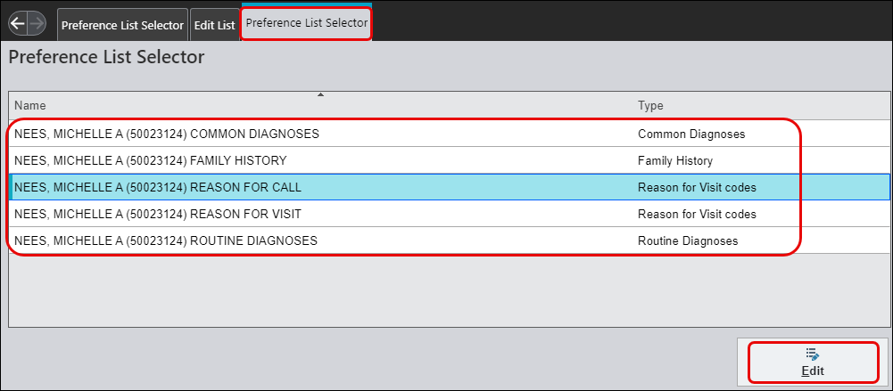

When you search for diagnoses in this section or visit taskbar (see below), you can search for your common and routine diagnosis preference lists. There are no speed buttons however. Your lists are only available while searching.
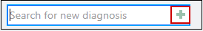

You can review your list by clicking on the green plus sign but you cannot make changes to your list from the green plus, you need to use the Preference List Editor to make those changes.

Appendix

Screening Labs

Weeks (Z3A series) cannot be the primary diagnosis on any order/study/visit.

Pertinent questions:
Is desired study for screening or for diagnosis?
Screening = Testing for condition in well individuals
Diagnosis = Testing to rule out or confirm a suspected diagnosis because the individual has a sign or symptom

Is there another diagnosis associated with CPT?
If there is a diagnosis code, do not add a screening code
Example: Ultrasound for 36-yo G1; use ICD10 O09.512 (AMA), not Z36.3 (routine screening)

